

Cif funnel runB
Report date | Jun 13, 2026, 5:14:01 PM

Contents
1. Global Definitions
1.1. Parameters
1.2. Shared Properties
2. Component 1
2.1. Definitions
2.2. Geometry 1
2.3. Materials
2.4. Creeping Flow
2.5. Mesh 1
3. Study 1
3.1. Stationary
3.2. Solver Configurations
4. Results
4.1. Datasets
4.2. Derived Values
4.3. Tables
4.4. Plot Groups

Global Definitions
Date | Jun 13, 2026, 9:09:52 AM

Global settings
Name | Cif funnel runB.mph
Path | Z:\Downloads\cif_funnel_runB.mph
Version | COMSOL Multiphysics 6.3 (Build: 420)
Unit system | SI

Used products
COMSOL Multiphysics
CAD Import Module
CFD Module

Computer information
CPU | Intel64 Family 6 Model 106 Stepping 6, 4 cores, 16 GB RAM
Operating system | Windows 11

Parameters
Parameters 1
Name | Expression | Value | Description
w_c | 100[um] | 1E−4 m
w_s | 60[um] | 6E−5 m
gap | 20[um] | 2E−5 m
depth | 140[um] | 1.4E−4 m
L_gap_x | 20[um] | 2E−5 m
L_entry | 100[um] | 1E−4 m
L_exit | 60[um] | 6E−5 m
L_x | L_entry + L_gap_x + L_exit | 1.8E−4 m
Q0 | 20[ul/min] | 3.3333E−10 m³/s
frac | 5e-4 | 5E−4
A_in | (w_c/2)*(depth/2) | 3.5E−9 m²
A_side | w_s*(depth/2) | 4.2E−9 m²
U_in | Q0/A_in | 0.095238 m/s
U_side | frac*Q0/A_side | 3.9683E−5 m/s
Q_gap | frac*Q0 | 1.6667E−13 m³/s

Shared Properties

Default Model Inputs
Tag | cminpt

Component 1
Date | Jun 13, 2026, 9:02:14 AM

Settings
Description | Value
Unit system | Same as global system (SI)
Geometry shape function | Automatic

Spatial frame coordinates
First | Second | Third
x | y | z

Material frame coordinates
First | Second | Third
X | Y | Z

Geometry frame coordinates
First | Second | Third
Xg | Yg | Zg

Mesh frame coordinates
First | Second | Third
Xm | Ym | Zm

Definitions

Selections

Inlet_Center
Selection type
Box

Selection
Boundary 1

Geometric entity level
Description | Value
Level | Boundary

Output entities
Description | Value
Include entity if | Entity inside box

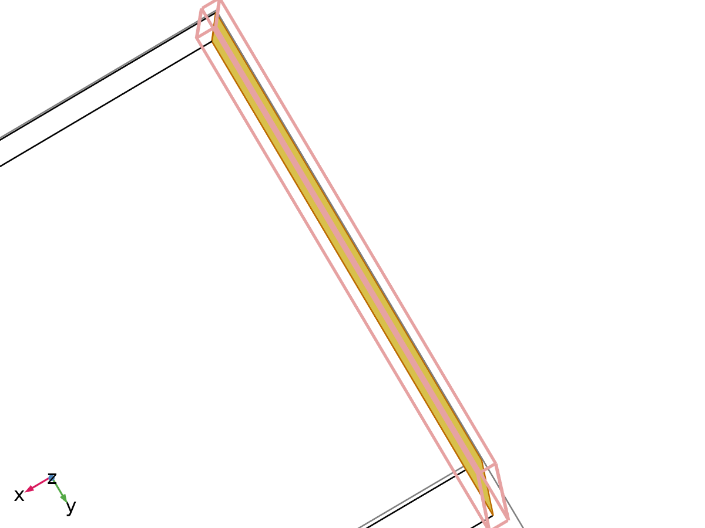
Inlet_Center

Outlet_Center
Selection type
Box

Selection
Boundary 19

Geometric entity level
Description | Value
Level | Boundary

Output entities
Description | Value
Include entity if | Entity inside box

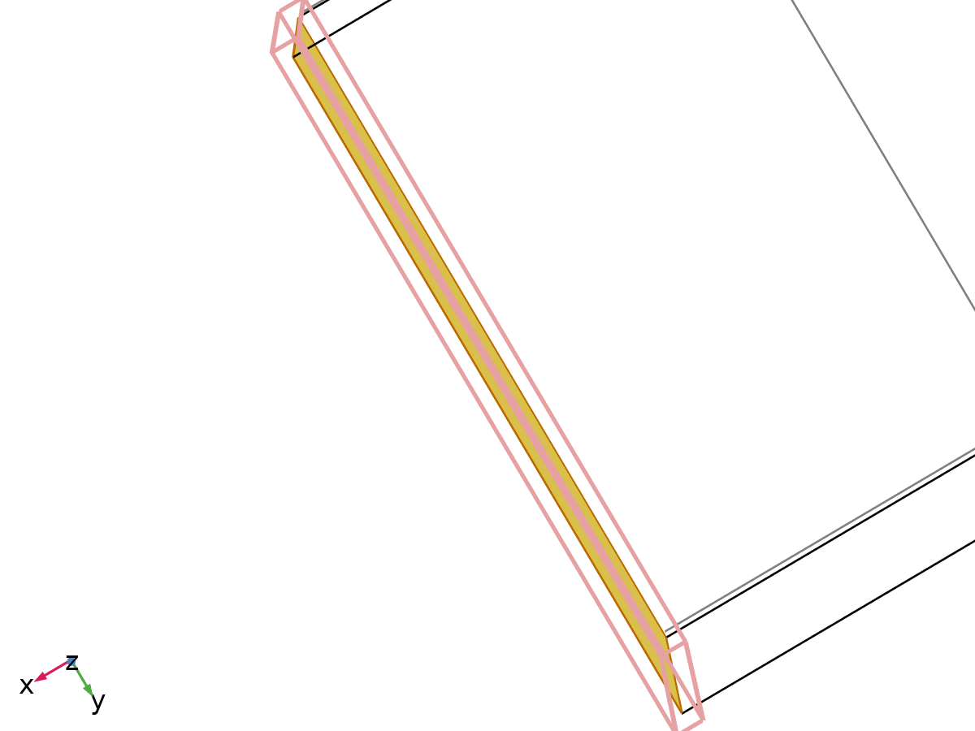
Outlet_Center

Outlet_Side
Selection type
Box

Selection
Boundary 20

Geometric entity level
Description | Value
Level | Boundary

Output entities
Description | Value
Include entity if | Entity inside box

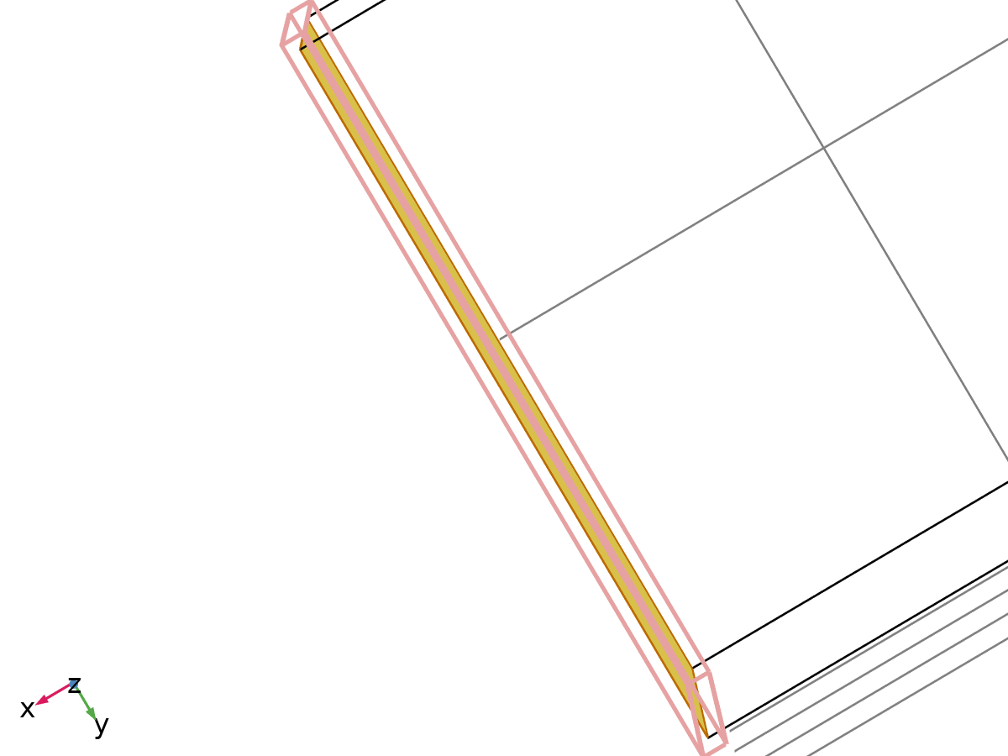
Outlet_Side

Sym_y0
Selection type
Box

Selection
Boundary 2

Geometric entity level
Description | Value
Level | Boundary

Output entities
Description | Value
Include entity if | Entity inside box

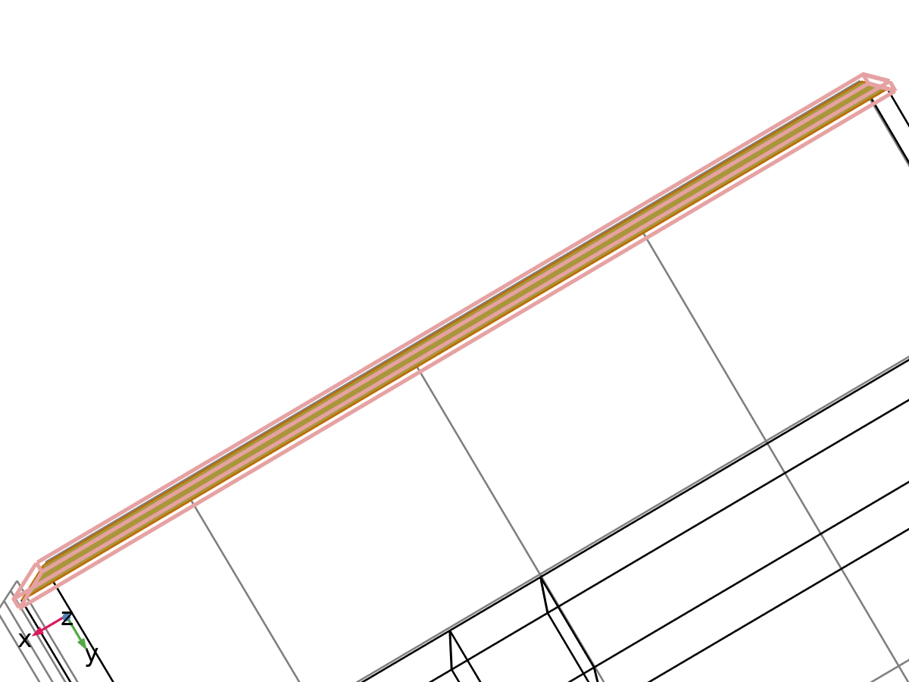
Sym_y0

Sym_zmid
Selection type
Box

Selection
Boundaries 4, 9, 14

Geometric entity level
Description | Value
Level | Boundary

Output entities
Description | Value
Include entity if | Entity inside box

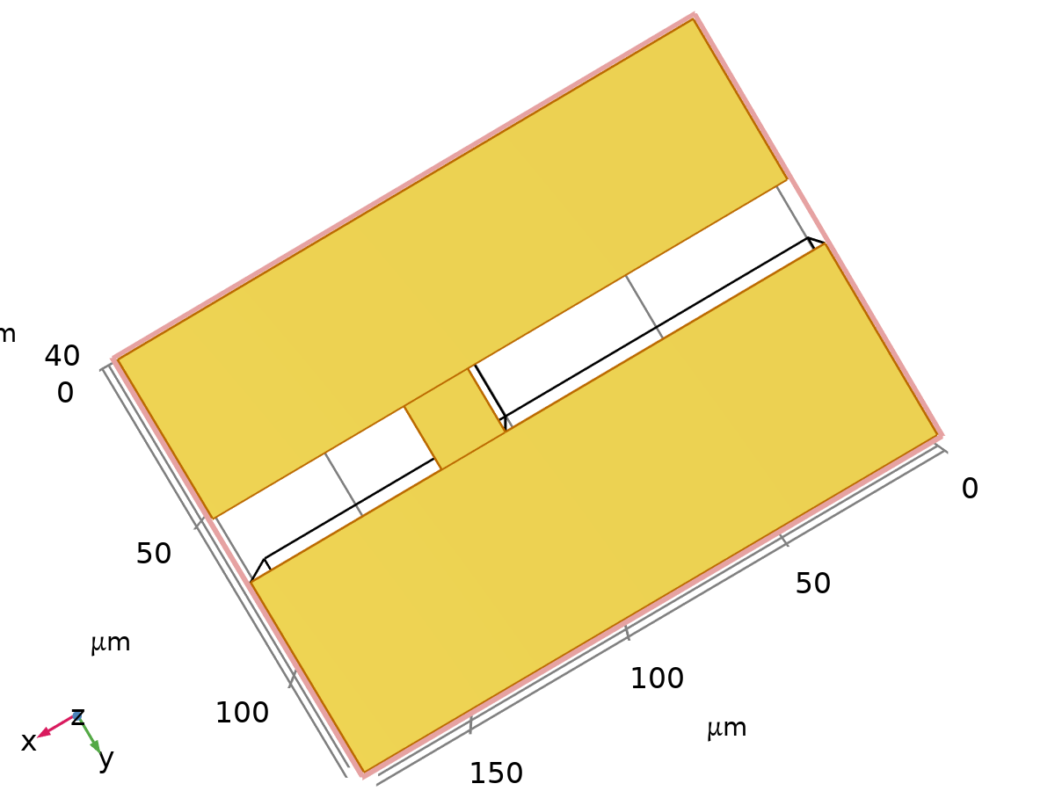
Sym_zmid

Wall_gap
Selection type
Box

Selection
Boundary 12

Geometric entity level
Description | Value
Level | Boundary

Output entities
Description | Value
Include entity if | Entity inside box

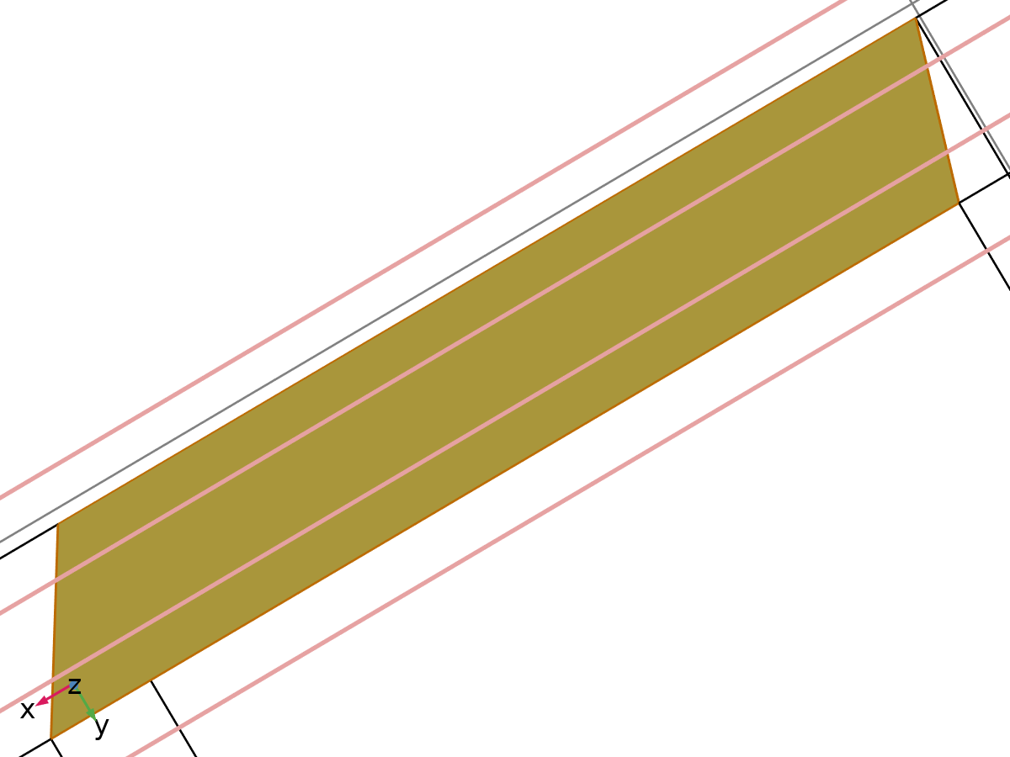
Wall_gap

Nonlocal Couplings

intop_in
Coupling type | Integration
Operator name | intop_in

Selection
Geometric entity level | Boundary
Name | Inlet Center
Selection | Named box1: Geometry geom1: Dimension 2: Boundary 1

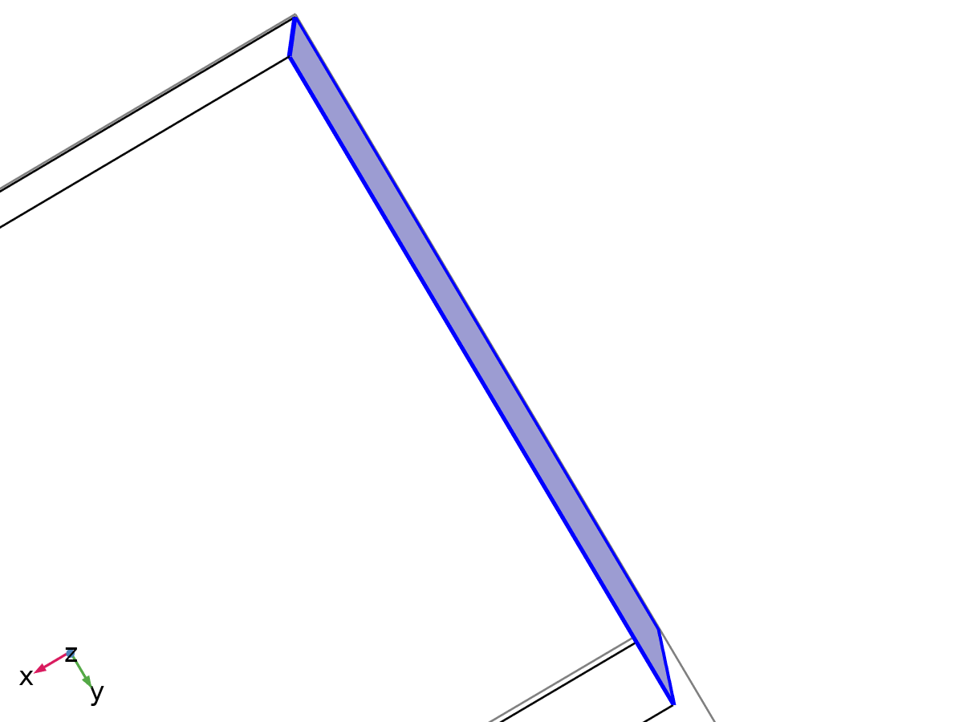
Selection

intop_cout
Coupling type | Integration
Operator name | intop_cout

Selection
Geometric entity level | Boundary
Name | Outlet Center
Selection | Named box2: Geometry geom1: Dimension 2: Boundary 19

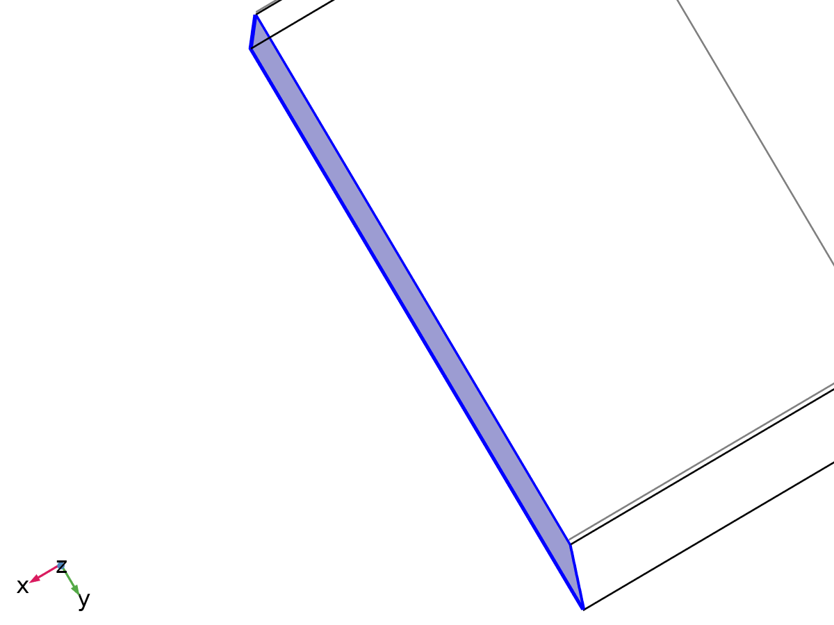
Selection

intop_sout
Coupling type | Integration
Operator name | intop_sout

Selection
Geometric entity level | Boundary
Name | Outlet Side
Selection | Named box3: Geometry geom1: Dimension 2: Boundary 20

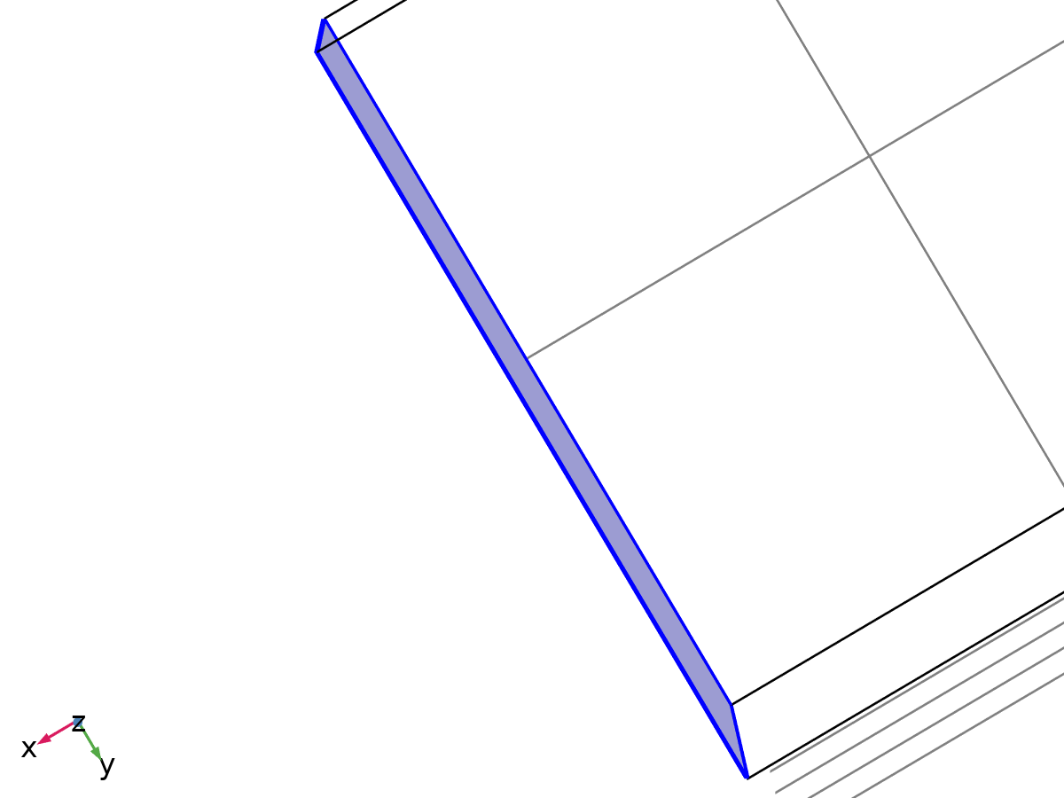
Selection

Coordinate Systems

Boundary System 1
Coordinate system type | Boundary system
Tag | sys1

Coordinate names
First | Second | Third
t1 | t2 | n

Geometry 1
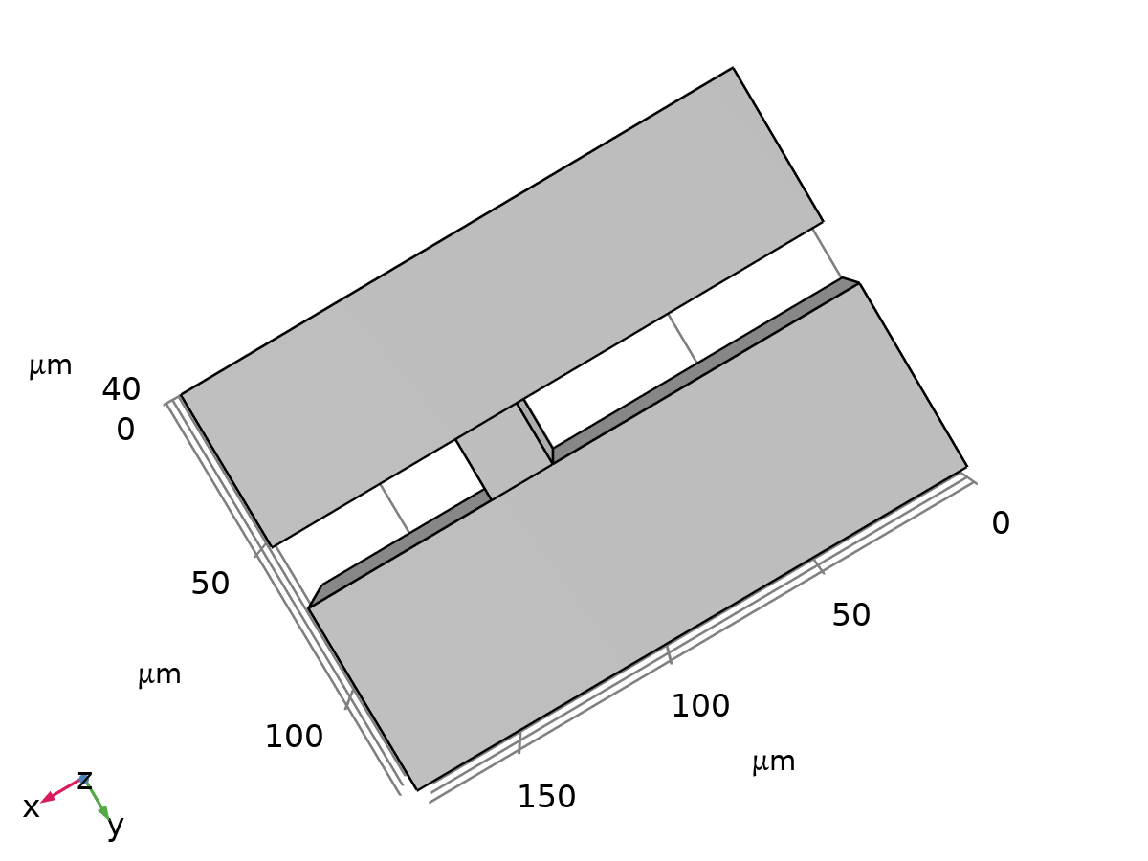
Geometry 1
Units
Length unit | µm
Angular unit | deg

Geometry statistics
Description | Value
Space dimension | 3
Number of domains | 3
Number of boundaries | 20
Number of edges | 40
Number of vertices | 24

Center Half-Channel (blk1)
Size and shape
Description | Value
Width | L_x
Depth | w_c/2
Height | depth/2

Position
Description | Value
Position | {0, 0, 0}

Axis
Description | Value
Axis type | z - axis

Gap Aperture (blk2)
Size and shape
Description | Value
Width | L_gap_x
Depth | gap
Height | depth/2

Position
Description | Value
Position | {L_entry, w_c/2, 0}

Axis
Description | Value
Axis type | z - axis

side channel (blk3)
Size and shape
Description | Value
Width | L_x
Depth | w_s
Height | depth/2

Position
Description | Value
Position | {0, w_c/2 + gap, 0}

Axis
Description | Value
Axis type | z - axis

Form Union (fin)
Information
Description | Value
Build message | Formed union of 3 solid objects.  Union has 3 domains, 20 boundaries, 40 edges, and 24 vertices.

Materials

PRP
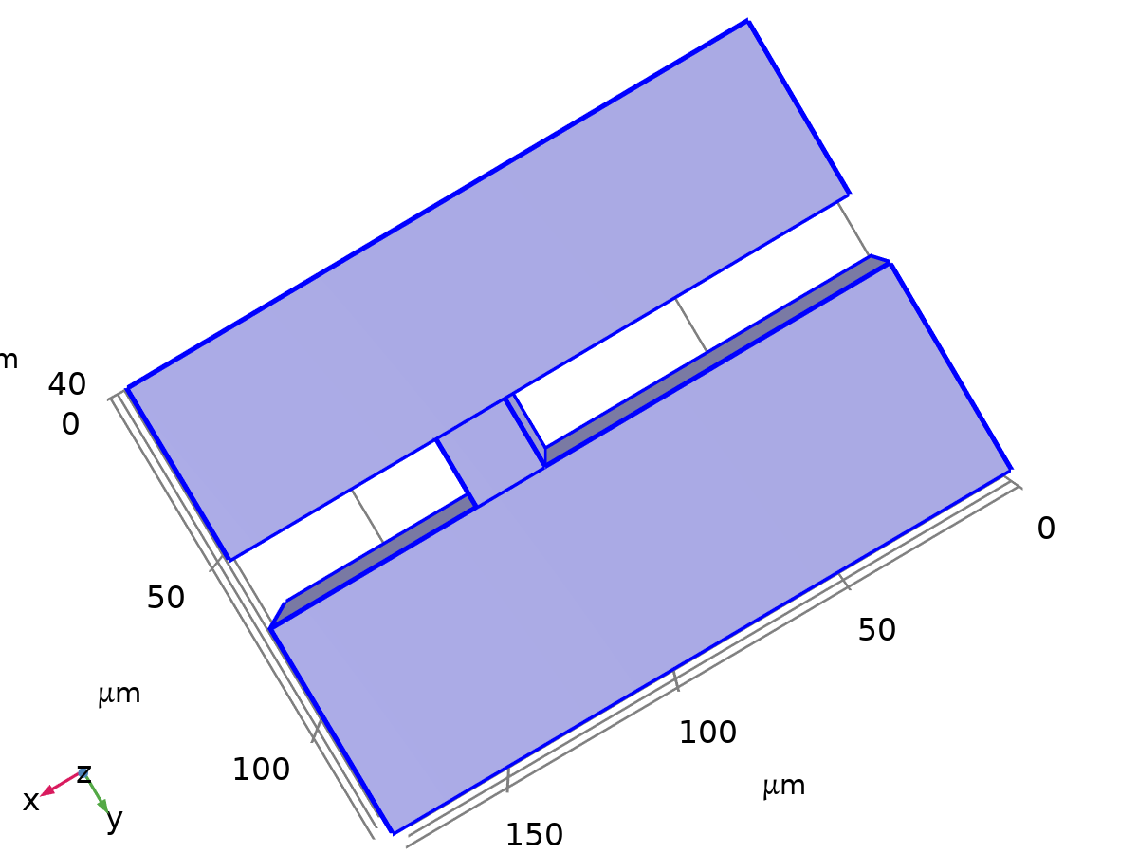
PRP
Selection
Geometric entity level | Domain
Selection | Geometry geom1: Dimension 3: All domains

Material parameters
Name | Value | Unit | Property group
Density | 1000 | kg/m³ | Basic
Dynamic viscosity | 0.0012 | Pa·s | Basic

Basic
Description | Value | Unit
Density | 1000 | kg/m³
Dynamic viscosity | 0.0012 | Pa·s

Creeping Flow
Used products
COMSOL Multiphysics
CFD Module

Creeping Flow
Selection
Geometric entity level | Domain
Selection | Geometry geom1: Dimension 3: All domains

Equations



Interface Settings

Discretization
Settings
Description | Value
Discretization of fluids | P2 + P1

Settings
Description | Value
Equation form | Study controlled

Physical Model
Settings
Description | Value | Unit
Neglect inertial term (Stokes flow) | On
Compressibility | Incompressible flow
Enable porous media domains | Off
Include gravity | Off
Reference temperature | User defined
Reference temperature | 293.15 | K
Reference pressure level | 1.0133E5 | Pa

Turbulence
Settings
Description | Value
Turbulence model type | None

Variables
Name | Expression | Unit | Description | Selection | Details
spf.Tref | model.input.Tref | K | Reference temperature | Global | Meta
spf.dz | 1 | m | Thickness | Domains 1–3
spf.pref | 1[atm] | Pa | Reference pressure level | Domains 1–3
spf.pA | p+spf.pref | Pa | Absolute pressure | Domains 1–3
spf.hasWF | 0 |  | Help variable | Boundaries 1–11, 13–14, 16–20
spf.hasWF_u | 0 |  | Help variable | Boundaries 12, 15
spf.hasWF_d | 0 |  | Help variable | Boundaries 12, 15
spf.dt_CFL | 1/max(spf.maxop(sqrt(emetric_spatial(u-d(x,TIME),v-d(y,TIME),w-d(z,TIME)))),eps) | s | Time step, CFL=1 | Global
spf.Qvd_tot | spf.intop(spf.Qvd) | W | Total viscous dissipation | Global
spf.K_stressx | spf.K_stress_tensorxx*spf.nxmesh+spf.K_stress_tensorxy*spf.nymesh+spf.K_stress_tensorxz*spf.nzmesh | N/m² | Viscous stress, exterior boundaries, x-component | Boundaries 1–11, 13–14, 16–20
spf.K_stressy | spf.K_stress_tensoryx*spf.nxmesh+spf.K_stress_tensoryy*spf.nymesh+spf.K_stress_tensoryz*spf.nzmesh | N/m² | Viscous stress, exterior boundaries, y-component | Boundaries 1–11, 13–14, 16–20
spf.K_stressz | spf.K_stress_tensorzx*spf.nxmesh+spf.K_stress_tensorzy*spf.nymesh+spf.K_stress_tensorzz*spf.nzmesh | N/m² | Viscous stress, exterior boundaries, z-component | Boundaries 1–11, 13–14, 16–20
spf.T_stressx | spf.T_stress_tensorxx*spf.nxmesh+spf.T_stress_tensorxy*spf.nymesh+spf.T_stress_tensorxz*spf.nzmesh | N/m² | Total traction, exterior boundaries, x-component | Boundaries 1–11, 13–14, 16–20
spf.T_stressy | spf.T_stress_tensoryx*spf.nxmesh+spf.T_stress_tensoryy*spf.nymesh+spf.T_stress_tensoryz*spf.nzmesh | N/m² | Total traction, exterior boundaries, y-component | Boundaries 1–11, 13–14, 16–20
spf.T_stressz | spf.T_stress_tensorzx*spf.nxmesh+spf.T_stress_tensorzy*spf.nymesh+spf.T_stress_tensorzz*spf.nzmesh | N/m² | Total traction, exterior boundaries, z-component | Boundaries 1–11, 13–14, 16–20
spf.K_stress_dx | down(spf.K_stress_tensorxx)*spf.nxmesh+down(spf.K_stress_tensorxy)*spf.nymesh+down(spf.K_stress_tensorxz)*spf.nzmesh | N/m² | Viscous stress, interior boundaries, downside, x-component | Boundaries 12, 15
spf.K_stress_dy | down(spf.K_stress_tensoryx)*spf.nxmesh+down(spf.K_stress_tensoryy)*spf.nymesh+down(spf.K_stress_tensoryz)*spf.nzmesh | N/m² | Viscous stress, interior boundaries, downside, y-component | Boundaries 12, 15
spf.K_stress_dz | down(spf.K_stress_tensorzx)*spf.nxmesh+down(spf.K_stress_tensorzy)*spf.nymesh+down(spf.K_stress_tensorzz)*spf.nzmesh | N/m² | Viscous stress, interior boundaries, downside, z-component | Boundaries 12, 15
spf.K_stress_dx | down(spf.K_stress_tensorxx)*spf.dnxmesh+down(spf.K_stress_tensorxy)*spf.dnymesh+down(spf.K_stress_tensorxz)*spf.dnzmesh | N/m² | Viscous stress, interior boundaries, downside, x-component | Boundaries 1–11, 13–14, 16–20
spf.K_stress_dy | down(spf.K_stress_tensoryx)*spf.dnxmesh+down(spf.K_stress_tensoryy)*spf.dnymesh+down(spf.K_stress_tensoryz)*spf.dnzmesh | N/m² | Viscous stress, interior boundaries, downside, y-component | Boundaries 1–11, 13–14, 16–20
spf.K_stress_dz | down(spf.K_stress_tensorzx)*spf.dnxmesh+down(spf.K_stress_tensorzy)*spf.dnymesh+down(spf.K_stress_tensorzz)*spf.dnzmesh | N/m² | Viscous stress, interior boundaries, downside, z-component | Boundaries 1–11, 13–14, 16–20
spf.K_stress_ux | -up(spf.K_stress_tensorxx)*spf.nxmesh-up(spf.K_stress_tensorxy)*spf.nymesh-up(spf.K_stress_tensorxz)*spf.nzmesh | N/m² | Viscous stress, interior boundaries, upside, x-component | Boundaries 12, 15
spf.K_stress_uy | -up(spf.K_stress_tensoryx)*spf.nxmesh-up(spf.K_stress_tensoryy)*spf.nymesh-up(spf.K_stress_tensoryz)*spf.nzmesh | N/m² | Viscous stress, interior boundaries, upside, y-component | Boundaries 12, 15
spf.K_stress_uz | -up(spf.K_stress_tensorzx)*spf.nxmesh-up(spf.K_stress_tensorzy)*spf.nymesh-up(spf.K_stress_tensorzz)*spf.nzmesh | N/m² | Viscous stress, interior boundaries, upside, z-component | Boundaries 12, 15
spf.T_stress_dx | down(spf.T_stress_tensorxx)*spf.nxmesh+down(spf.T_stress_tensorxy)*spf.nymesh+down(spf.T_stress_tensorxz)*spf.nzmesh | N/m² | Total traction, interior boundaries, downside, x-component | Boundaries 12, 15
spf.T_stress_dy | down(spf.T_stress_tensoryx)*spf.nxmesh+down(spf.T_stress_tensoryy)*spf.nymesh+down(spf.T_stress_tensoryz)*spf.nzmesh | N/m² | Total traction, interior boundaries, downside, y-component | Boundaries 12, 15
spf.T_stress_dz | down(spf.T_stress_tensorzx)*spf.nxmesh+down(spf.T_stress_tensorzy)*spf.nymesh+down(spf.T_stress_tensorzz)*spf.nzmesh | N/m² | Total traction, interior boundaries, downside, z-component | Boundaries 12, 15
spf.T_stress_dx | down(spf.T_stress_tensorxx)*spf.dnxmesh+down(spf.T_stress_tensorxy)*spf.dnymesh+down(spf.T_stress_tensorxz)*spf.dnzmesh | N/m² | Total traction, interior boundaries, downside, x-component | Boundaries 1–11, 13–14, 16–20
spf.T_stress_dy | down(spf.T_stress_tensoryx)*spf.dnxmesh+down(spf.T_stress_tensoryy)*spf.dnymesh+down(spf.T_stress_tensoryz)*spf.dnzmesh | N/m² | Total traction, interior boundaries, downside, y-component | Boundaries 1–11, 13–14, 16–20
spf.T_stress_dz | down(spf.T_stress_tensorzx)*spf.dnxmesh+down(spf.T_stress_tensorzy)*spf.dnymesh+down(spf.T_stress_tensorzz)*spf.dnzmesh | N/m² | Total traction, interior boundaries, downside, z-component | Boundaries 1–11, 13–14, 16–20
spf.T_stress_ux | -up(spf.T_stress_tensorxx)*spf.nxmesh-up(spf.T_stress_tensorxy)*spf.nymesh-up(spf.T_stress_tensorxz)*spf.nzmesh | N/m² | Total traction, interior boundaries, upside, x-component | Boundaries 12, 15
spf.T_stress_uy | -up(spf.T_stress_tensoryx)*spf.nxmesh-up(spf.T_stress_tensoryy)*spf.nymesh-up(spf.T_stress_tensoryz)*spf.nzmesh | N/m² | Total traction, interior boundaries, upside, y-component | Boundaries 12, 15
spf.T_stress_uz | -up(spf.T_stress_tensorzx)*spf.nxmesh-up(spf.T_stress_tensorzy)*spf.nymesh-up(spf.T_stress_tensorzz)*spf.nzmesh | N/m² | Total traction, interior boundaries, upside, z-component | Boundaries 12, 15
spf.T_tracx | spf.T_stressx | N/m² | Total applied traction, exterior boundaries, x-component | Boundaries 1–11, 13–14, 16–20
spf.T_tracy | spf.T_stressy | N/m² | Total applied traction, exterior boundaries, y-component | Boundaries 1–11, 13–14, 16–20
spf.T_tracz | spf.T_stressz | N/m² | Total applied traction, exterior boundaries, z-component | Boundaries 1–11, 13–14, 16–20
spf.T_trac_dx | spf.T_stress_dx | N/m² | Total applied traction, downside boundaries, x-component | Boundaries 12, 15
spf.T_trac_dy | spf.T_stress_dy | N/m² | Total applied traction, downside boundaries, y-component | Boundaries 12, 15
spf.T_trac_dz | spf.T_stress_dz | N/m² | Total applied traction, downside boundaries, z-component | Boundaries 12, 15
spf.T_trac_dx | spf.T_stress_dx | N/m² | Total applied traction, downside boundaries, x-component | Boundaries 1–11, 13–14, 16–20
spf.T_trac_dy | spf.T_stress_dy | N/m² | Total applied traction, downside boundaries, y-component | Boundaries 1–11, 13–14, 16–20
spf.T_trac_dz | spf.T_stress_dz | N/m² | Total applied traction, downside boundaries, z-component | Boundaries 1–11, 13–14, 16–20
spf.T_trac_ux | spf.T_stress_ux | N/m² | Total applied traction, upside boundaries, x-component | Boundaries 12, 15
spf.T_trac_uy | spf.T_stress_uy | N/m² | Total applied traction, upside boundaries, y-component | Boundaries 12, 15
spf.T_trac_uz | spf.T_stress_uz | N/m² | Total applied traction, upside boundaries, z-component | Boundaries 12, 15
spf.usePseudoTimeStepping | isrunningpseudotimestepping | 1 | Help variable | Global
spf.localCFLvalue | 1.3^min(niterCMP,9)+if(niterCMP>=25,9*1.3^min(-25+niterCMP,9),0)+if(niterCMP>=45,90*1.3^min(-45+niterCMP,9),0) |  | Local CFL number | Domains 1–3
spf.locCFL | max(CFLCMP,sqrt(eps)) | 1 | Local CFL number | Global
spf.geometryLengthScale | 1.75E-5 | m | Geometry length scale | Domains 1–3
spf.time_step_inv | max(sqrt(emetric_spatial(u,v,w)*2^if(gmg_level<2,0,-1+gmg_level)^2),spf.nu/spf.geometryLengthScale^2) | Hz | Inverse time step | Domains 1–3
spf.tsti | nojac(spf.time_step_inv/spf.locCFL) | 1/s | Help variable | Domains 1–3
spf.nx | nx | 1 | Normal vector, x-component | Boundaries 12, 15
spf.ny | ny | 1 | Normal vector, y-component | Boundaries 12, 15
spf.nz | nz | 1 | Normal vector, z-component | Boundaries 12, 15
spf.nx | dnx | 1 | Normal vector, x-component | Boundaries 1–11, 13–14, 16–20
spf.ny | dny | 1 | Normal vector, y-component | Boundaries 1–11, 13–14, 16–20
spf.nz | dnz | 1 | Normal vector, z-component | Boundaries 1–11, 13–14, 16–20
spf.nxmesh | nxmesh | 1 | Normal vector, x-component | Boundaries 12, 15
spf.nymesh | nymesh | 1 | Normal vector, y-component | Boundaries 12, 15
spf.nzmesh | nzmesh | 1 | Normal vector, z-component | Boundaries 12, 15
spf.nxmesh | dnxmesh | 1 | Normal vector, x-component | Boundaries 1–11, 13–14, 16–20
spf.nymesh | dnymesh | 1 | Normal vector, y-component | Boundaries 1–11, 13–14, 16–20
spf.nzmesh | dnzmesh | 1 | Normal vector, z-component | Boundaries 1–11, 13–14, 16–20

Fluid Properties 1
Fluid Properties 1
Selection
Geometric entity level | Domain
Selection | Geometry geom1: Dimension 3: All domains

Equations
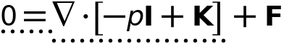
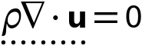


Fluid Properties
Settings
Description | Value
Density | From material
Constitutive relation | Specify dynamic viscosity
Dynamic viscosity | From material

Model Input
Settings
Description | Value
Temperature | Common model input

Properties from material
Property | Material | Property group
Density | PRP | Basic
Dynamic viscosity | PRP | Basic

Variables
Name | Expression | Unit | Description | Selection | Details
spf.mu | material.mu | Pa·s | Dynamic viscosity | Domains 1–3 | Meta
spf.rho | subst(material.rho,spf.fp1.minput_temperature,spf.Trho,spf.fp1.minput_pressure,spf.prho) | kg/m³ | Density | Domains 1–3 | Meta
spf.Trho | spf.Tref | K | Temperature for density evaluation | Domains 1–3
spf.prho | spf.pref | Pa | Pressure for the evaluation of density | Domains 1–3
spf.rhoref | subst(material.rho,spf.fp1.minput_temperature,spf.Tref,spf.fp1.minput_pressure,spf.pref) | kg/m³ | Reference density | Domains 1–3 | Meta
spf.mumat | material.mu | Pa·s | Dynamic viscosity | Domains 1–3 | Meta
spf.srijxx | ux | 1/s | Strain rate tensor, xx-component | Domains 1–3
spf.srijyx | 0.5*(vx+uy) | 1/s | Strain rate tensor, yx-component | Domains 1–3
spf.srijzx | 0.5*(wx+uz) | 1/s | Strain rate tensor, zx-component | Domains 1–3
spf.srijxy | 0.5*(uy+vx) | 1/s | Strain rate tensor, xy-component | Domains 1–3
spf.srijyy | vy | 1/s | Strain rate tensor, yy-component | Domains 1–3
spf.srijzy | 0.5*(wy+vz) | 1/s | Strain rate tensor, zy-component | Domains 1–3
spf.srijxz | 0.5*(uz+wx) | 1/s | Strain rate tensor, xz-component | Domains 1–3
spf.srijyz | 0.5*(vz+wy) | 1/s | Strain rate tensor, yz-component | Domains 1–3
spf.srijzz | wz | 1/s | Strain rate tensor, zz-component | Domains 1–3
spf.rrijxx | 0 | 1/s | Rotation rate tensor, xx-component | Domains 1–3
spf.rrijyx | 0.5*(vx-uy) | 1/s | Rotation rate tensor, yx-component | Domains 1–3
spf.rrijzx | 0.5*(wx-uz) | 1/s | Rotation rate tensor, zx-component | Domains 1–3
spf.rrijxy | 0.5*(uy-vx) | 1/s | Rotation rate tensor, xy-component | Domains 1–3
spf.rrijyy | 0 | 1/s | Rotation rate tensor, yy-component | Domains 1–3
spf.rrijzy | 0.5*(wy-vz) | 1/s | Rotation rate tensor, zy-component | Domains 1–3
spf.rrijxz | 0.5*(uz-wx) | 1/s | Rotation rate tensor, xz-component | Domains 1–3
spf.rrijyz | 0.5*(vz-wy) | 1/s | Rotation rate tensor, yz-component | Domains 1–3
spf.rrijzz | 0 | 1/s | Rotation rate tensor, zz-component | Domains 1–3
spf.sr | sqrt(2*spf.srijxx^2+2*spf.srijxy^2+2*spf.srijxz^2+2*spf.srijyx^2+2*spf.srijyy^2+2*spf.srijyz^2+2*spf.srijzx^2+2*spf.srijzy^2+2*spf.srijzz^2+eps) | 1/s | Shear rate | Domains 1–3
spf.rr | sqrt(2*spf.rrijxx^2+2*spf.rrijxy^2+2*spf.rrijxz^2+2*spf.rrijyx^2+2*spf.rrijyy^2+2*spf.rrijyz^2+2*spf.rrijzx^2+2*spf.rrijzy^2+2*spf.rrijzz^2+eps) | 1/s | Rotation rate | Domains 1–3
spf.divu | ux+vy+wz | 1/s | Divergence of velocity field | Domains 1–3
spf.Fx | 0 | N/m³ | Volume force, x-component | Domains 1–3 | + operation
spf.Fy | 0 | N/m³ | Volume force, y-component | Domains 1–3 | + operation
spf.Fz | 0 | N/m³ | Volume force, z-component | Domains 1–3 | + operation
spf.U | sqrt(u^2+v^2+w^2) | m/s | Velocity magnitude | Domains 1–3
spf.vorticityx | wy-vz | 1/s | Vorticity field, x-component | Domains 1–3
spf.vorticityy | -wx+uz | 1/s | Vorticity field, y-component | Domains 1–3
spf.vorticityz | vx-uy | 1/s | Vorticity field, z-component | Domains 1–3
spf.vort_magn | sqrt(spf.vorticityx^2+spf.vorticityy^2+spf.vorticityz^2) | 1/s | Vorticity magnitude | Domains 1–3
spf.cellRe | 0.25*spf.rho*sqrt(emetric_spatial(u-d(x,TIME),v-d(y,TIME),w-d(z,TIME))/emetric2_spatial)/spf.mu | 1 | Cell Reynolds number | Domains 1–3
spf.nu | spf.mu/spf.rho | m²/s | Kinematic viscosity | Domains 1–3
spf.betaT | 0 | 1/Pa | Isothermal compressibility coefficient | Domains 1–3
spf.Qm | 0 | kg/(m³·s) | Source term | Domains 1–3 | + operation
spf.Fgtotx | 0 | N/m³ | Gravity force, x-component | Domains 1–3 | + operation
spf.Fgtoty | 0 | N/m³ | Gravity force, y-component | Domains 1–3 | + operation
spf.Fgtotz | 0 | N/m³ | Gravity force, z-component | Domains 1–3 | + operation
spf.Qm_aco | 0 | kg/(m³·s) | Acoustic mass source | Domains 1–3
spf.F_acox | 0 | N/m³ | Acoustic volume force, x-component | Domains 1–3
spf.F_acoy | 0 | N/m³ | Acoustic volume force, y-component | Domains 1–3
spf.F_acoz | 0 | N/m³ | Acoustic volume force, z-component | Domains 1–3
spf.gamma_sr | sqrt(2*spf.srijxx^2+2*spf.srijxy^2+2*spf.srijxz^2+2*spf.srijyx^2+2*spf.srijyy^2+2*spf.srijyz^2+2*spf.srijzx^2+2*spf.srijzy^2+2*spf.srijzz^2+eps) | 1/s | Shear rate | Domains 1–3
spf.mu_eff | spf.mu+spf.muT | Pa·s | Effective dynamic viscosity | Domains 1–3
spf.muT | 0 | Pa·s | Turbulent dynamic viscosity | Domains 1–3 | + operation
spf.T_stress_tensorxx | spf.K_stress_tensorxx-p | N/m² | Total stress tensor, xx-component | Domains 1–3 | + operation
spf.T_stress_tensoryx | spf.K_stress_tensoryx | N/m² | Total stress tensor, yx-component | Domains 1–3 | + operation
spf.T_stress_tensorzx | spf.K_stress_tensorzx | N/m² | Total stress tensor, zx-component | Domains 1–3 | + operation
spf.T_stress_tensorxy | spf.K_stress_tensorxy | N/m² | Total stress tensor, xy-component | Domains 1–3 | + operation
spf.T_stress_tensoryy | spf.K_stress_tensoryy-p | N/m² | Total stress tensor, yy-component | Domains 1–3 | + operation
spf.T_stress_tensorzy | spf.K_stress_tensorzy | N/m² | Total stress tensor, zy-component | Domains 1–3 | + operation
spf.T_stress_tensorxz | spf.K_stress_tensorxz | N/m² | Total stress tensor, xz-component | Domains 1–3 | + operation
spf.T_stress_tensoryz | spf.K_stress_tensoryz | N/m² | Total stress tensor, yz-component | Domains 1–3 | + operation
spf.T_stress_tensorzz | spf.K_stress_tensorzz-p | N/m² | Total stress tensor, zz-component | Domains 1–3 | + operation
spf.K_stress_tensorxx | 2*spf.mu_eff*ux | N/m² | Viscous stress tensor, xx-component | Domains 1–3 | + operation
spf.K_stress_tensoryx | spf.mu_eff*(vx+uy) | N/m² | Viscous stress tensor, yx-component | Domains 1–3 | + operation
spf.K_stress_tensorzx | spf.mu_eff*(wx+uz) | N/m² | Viscous stress tensor, zx-component | Domains 1–3 | + operation
spf.K_stress_tensorxy | spf.mu_eff*(uy+vx) | N/m² | Viscous stress tensor, xy-component | Domains 1–3 | + operation
spf.K_stress_tensoryy | 2*spf.mu_eff*vy | N/m² | Viscous stress tensor, yy-component | Domains 1–3 | + operation
spf.K_stress_tensorzy | spf.mu_eff*(wy+vz) | N/m² | Viscous stress tensor, zy-component | Domains 1–3 | + operation
spf.K_stress_tensorxz | spf.mu_eff*(uz+wx) | N/m² | Viscous stress tensor, xz-component | Domains 1–3 | + operation
spf.K_stress_tensoryz | spf.mu_eff*(vz+wy) | N/m² | Viscous stress tensor, yz-component | Domains 1–3 | + operation
spf.K_stress_tensorzz | 2*spf.mu_eff*wz | N/m² | Viscous stress tensor, zz-component | Domains 1–3 | + operation
spf.K_stress_tensor_testxx | 2*spf.mu_eff*test(ux) | N/m² | Viscous stress tensor test, xx-component | Domains 1–3 | + operation
spf.K_stress_tensor_testyx | spf.mu_eff*(test(vx)+test(uy)) | N/m² | Viscous stress tensor test, yx-component | Domains 1–3 | + operation
spf.K_stress_tensor_testzx | spf.mu_eff*(test(wx)+test(uz)) | N/m² | Viscous stress tensor test, zx-component | Domains 1–3 | + operation
spf.K_stress_tensor_testxy | spf.mu_eff*(test(uy)+test(vx)) | N/m² | Viscous stress tensor test, xy-component | Domains 1–3 | + operation
spf.K_stress_tensor_testyy | 2*spf.mu_eff*test(vy) | N/m² | Viscous stress tensor test, yy-component | Domains 1–3 | + operation
spf.K_stress_tensor_testzy | spf.mu_eff*(test(wy)+test(vz)) | N/m² | Viscous stress tensor test, zy-component | Domains 1–3 | + operation
spf.K_stress_tensor_testxz | spf.mu_eff*(test(uz)+test(wx)) | N/m² | Viscous stress tensor test, xz-component | Domains 1–3 | + operation
spf.K_stress_tensor_testyz | spf.mu_eff*(test(vz)+test(wy)) | N/m² | Viscous stress tensor test, yz-component | Domains 1–3 | + operation
spf.K_stress_tensor_testzz | 2*spf.mu_eff*test(wz) | N/m² | Viscous stress tensor test, zz-component | Domains 1–3 | + operation
spf.upwind_helpx | -d(x,TIME) | m/s | Upwind term, x-component | Domains 1–3 | + operation
spf.upwind_helpy | -d(y,TIME) | m/s | Upwind term, y-component | Domains 1–3 | + operation
spf.upwind_helpz | -d(z,TIME) | m/s | Upwind term, z-component | Domains 1–3 | + operation
spf.continuityEquation | spf.rho*spf.divu-spf.Qm | kg/(m³·s) | Continuity equation | Domains 1–3
spf.contCoeff | spf.rho | kg/m³ | Help variable | Domains 1–3
spf.Qvd | spf.K_stress_tensorxx*ux+spf.K_stress_tensorxy*uy+spf.K_stress_tensorxz*uz+spf.K_stress_tensoryx*vx+spf.K_stress_tensoryy*vy+spf.K_stress_tensoryz*vz+spf.K_stress_tensorzx*wx+spf.K_stress_tensorzy*wy+spf.K_stress_tensorzz*wz | W/m³ | Viscous dissipation | Domains 1–3 | + operation
spf.epsilon_p | 1 | 1 | Porosity | Domains 1–3
spf.epsilon_p_pos | max(1,sqrt(eps)) | 1 | Positive porosity | Domains 1–3
spf.Fst_tensorxx | 0 | N/m² | Surface tension force, xx-component | Domains 1–3 | + operation
spf.Fst_tensoryx | 0 | N/m² | Surface tension force, yx-component | Domains 1–3 | + operation
spf.Fst_tensorzx | 0 | N/m² | Surface tension force, zx-component | Domains 1–3 | + operation
spf.Fst_tensorxy | 0 | N/m² | Surface tension force, xy-component | Domains 1–3 | + operation
spf.Fst_tensoryy | 0 | N/m² | Surface tension force, yy-component | Domains 1–3 | + operation
spf.Fst_tensorzy | 0 | N/m² | Surface tension force, zy-component | Domains 1–3 | + operation
spf.Fst_tensorxz | 0 | N/m² | Surface tension force, xz-component | Domains 1–3 | + operation
spf.Fst_tensoryz | 0 | N/m² | Surface tension force, yz-component | Domains 1–3 | + operation
spf.Fst_tensorzz | 0 | N/m² | Surface tension force, zz-component | Domains 1–3 | + operation
spf.res_u | px-(d(2*ux,x)+d(uy+vx,y)+d(uz+wx,z))*spf.mu-spf.Fx | N/m³ | Equation residual | Domains 1–3
spf.res_v | py-(d(vx+uy,x)+d(2*vy,y)+d(vz+wy,z))*spf.mu-spf.Fy | N/m³ | Equation residual | Domains 1–3
spf.res_w | pz-(d(wx+uz,x)+d(wy+vz,y)+d(2*wz,z))*spf.mu-spf.Fz | N/m³ | Equation residual | Domains 1–3
spf.res_p | spf.rho*spf.divu-spf.Qm | kg/(m³·s) | Pressure equation residual | Domains 1–3

Shape functions
Name | Shape function | Unit | Description | Shape frame | Selection
u | Lagrange (Quadratic) | m/s | Velocity field, x-component | Spatial | Domains 1–3
v | Lagrange (Quadratic) | m/s | Velocity field, y-component | Spatial | Domains 1–3
w | Lagrange (Quadratic) | m/s | Velocity field, z-component | Spatial | Domains 1–3
p | Lagrange (Linear) | Pa | Pressure | Spatial | Domains 1–3

Weak Expressions
Weak expression | Integration order | Integration frame | Selection
(p-spf.K_stress_tensorxx)*test(ux)-spf.K_stress_tensorxy*test(uy)-spf.K_stress_tensorxz*test(uz)-spf.K_stress_tensoryx*test(vx)+(p-spf.K_stress_tensoryy)*test(vy)-spf.K_stress_tensoryz*test(vz)-spf.K_stress_tensorzx*test(wx)-spf.K_stress_tensorzy*test(wy)+(p-spf.K_stress_tensorzz)*test(wz) | 4 | Spatial | Domains 1–3
spf.Fx*test(u)+spf.Fy*test(v)+spf.Fz*test(w) | 4 | Spatial | Domains 1–3
-spf.continuityEquation*test(p) | 4 | Spatial | Domains 1–3
spf.streamlinens | 4 | Spatial | Domains 1–3
if(spf.usePseudoTimeStepping>0,spf.rho*spf.tsti,0)*(-(u-nojac(u))*test(u)-(v-nojac(v))*test(v)-(w-nojac(w))*test(w)) | 4 | Spatial | Domains 1–3

Initial Values 1
Initial Values 1
Selection
Geometric entity level | Domain
Selection | Geometry geom1: Dimension 3: All domains

Initial Values
Settings
Description | Value | Unit
Velocity field, x-component | 0 | m/s
Velocity field, y-component | 0 | m/s
Velocity field, z-component | 0 | m/s
Pressure | 0 | Pa

Coordinate System Selection
Settings
Description | Value
Coordinate system | Global coordinate system

Variables
Name | Expression | Unit | Description | Selection
spf.u_initx | 0 | m/s | Velocity field, x-component | Domains 1–3
spf.u_inity | 0 | m/s | Velocity field, y-component | Domains 1–3
spf.u_initz | 0 | m/s | Velocity field, z-component | Domains 1–3
spf.p_init | 0 | Pa | Pressure | Domains 1–3

Wall 1
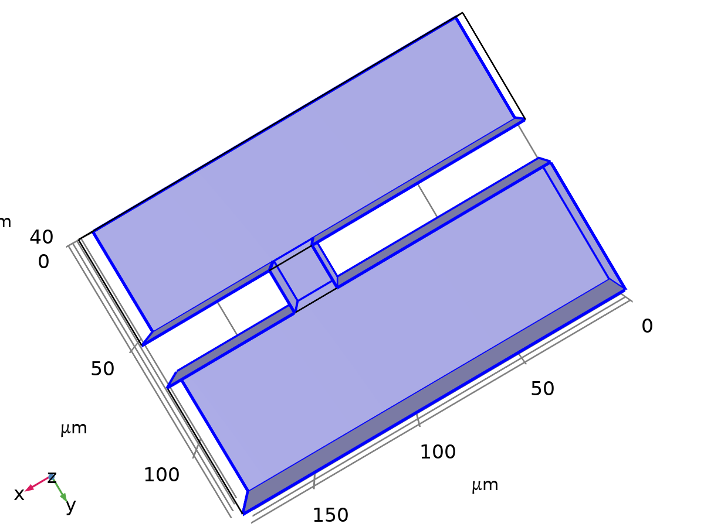
Wall 1
Selection
Geometric entity level | Boundary
Selection | Geometry geom1: Dimension 2: All boundaries

Equations


Boundary Condition
Settings
Description | Value
Wall condition | No slip

Wall Movement
Settings
Description | Value
Translational velocity | Automatic from frame
Sliding wall | Off

Variables
Name | Expression | Unit | Description | Selection | Details
spf.ubndx | spf.utrx+spf.usx | m/s | Velocity at boundary, x-component | Boundaries 3, 5–8, 10–11, 13, 16–18
spf.ubndy | spf.utry+spf.usy | m/s | Velocity at boundary, y-component | Boundaries 3, 5–8, 10–11, 13, 16–18
spf.ubndz | spf.utrz+spf.usz | m/s | Velocity at boundary, z-component | Boundaries 3, 5–8, 10–11, 13, 16–18
spf.usx | 0 | m/s | Velocity of sliding wall, x-component | Boundaries 3, 5–8, 10–11, 13, 16–18
spf.usy | 0 | m/s | Velocity of sliding wall, y-component | Boundaries 3, 5–8, 10–11, 13, 16–18
spf.usz | 0 | m/s | Velocity of sliding wall, z-component | Boundaries 3, 5–8, 10–11, 13, 16–18
spf.utrx | 0 | m/s | Velocity of moving wall, x-component | Boundaries 3, 5–8, 10–11, 13, 16–18
spf.utry | 0 | m/s | Velocity of moving wall, y-component | Boundaries 3, 5–8, 10–11, 13, 16–18
spf.utrz | 0 | m/s | Velocity of moving wall, z-component | Boundaries 3, 5–8, 10–11, 13, 16–18
spf.uLeakagex | 0 | m/s | Leakage velocity, x-component | Boundaries 3, 5–8, 10–11, 13, 16–18 | + operation
spf.uLeakagey | 0 | m/s | Leakage velocity, y-component | Boundaries 3, 5–8, 10–11, 13, 16–18 | + operation
spf.uLeakagez | 0 | m/s | Leakage velocity, z-component | Boundaries 3, 5–8, 10–11, 13, 16–18 | + operation
spf.noSlipWall | 1 | 1 | Help variable | Boundaries 3, 5–8, 10–11, 13, 16–18

Constraints
Constraint | Constraint force | Shape function | Selection | Details
-u+spf.ubndx+spf.uLeakagex | test(-u) | Lagrange (Quadratic) | Boundaries 3, 5–8, 10–11, 13, 16–18 | Elemental
-v+spf.ubndy+spf.uLeakagey | test(-v) | Lagrange (Quadratic) | Boundaries 3, 5–8, 10–11, 13, 16–18 | Elemental
-w+spf.ubndz+spf.uLeakagez | test(-w) | Lagrange (Quadratic) | Boundaries 3, 5–8, 10–11, 13, 16–18 | Elemental

Inlet 1
Inlet 1
Selection
Geometric entity level | Boundary
Name | Inlet Center
Selection | Named box1: Geometry geom1: Dimension 2: Boundary 1

Equations
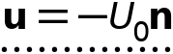

Boundary Condition
Settings
Description | Value
Boundary condition | Velocity

Velocity
Settings
Description | Value | Unit
Velocity field componentwise | Normal inflow velocity
Normal inflow velocity | U_in | m/s

Variables
Name | Expression | Unit | Description | Selection
spf.ubndx | -nojac(spf.nxmesh)*spf.U0in | m/s | Velocity at boundary, x-component | Boundary 1
spf.ubndy | -nojac(spf.nymesh)*spf.U0in | m/s | Velocity at boundary, y-component | Boundary 1
spf.ubndz | -nojac(spf.nzmesh)*spf.U0in | m/s | Velocity at boundary, z-component | Boundary 1
spf.U0in | U_in | m/s | Normal inflow velocity | Boundary 1
spf.inl1.dz | spf.dz | m | Channel thickness | Boundary 1
spf.inl1.volumeFlowRate | spf.inl1.intop(u*spf.nxmesh+v*spf.nymesh+w*spf.nzmesh) | m³/s | Outward volume flow rate across feature selection | Global
spf.inl1.massFlowRate | spf.inl1.intop(spf.rho*(u*spf.nxmesh+v*spf.nymesh+w*spf.nzmesh)) | kg/s | Outward mass flow rate across feature selection | Global
spf.inl1.pAverage | spf.inl1.aveop(p) | Pa | Pressure average over feature selection | Global

Constraints
Constraint | Constraint force | Shape function | Selection | Details
-u+spf.ubndx | test(-u) | Lagrange (Quadratic) | Boundary 1 | Elemental
-v+spf.ubndy | test(-v) | Lagrange (Quadratic) | Boundary 1 | Elemental
-w+spf.ubndz | test(-w) | Lagrange (Quadratic) | Boundary 1 | Elemental

Outlet 1
Outlet 1
Selection
Geometric entity level | Boundary
Name | Outlet Center
Selection | Named box2: Geometry geom1: Dimension 2: Boundary 19

Equations



Boundary Condition
Settings
Description | Value
Boundary condition | Pressure

Pressure Conditions
Settings
Description | Value | Unit
Pressure | Static
Pressure | 0 | Pa
Normal flow | On
Suppress backflow | On

Variables
Name | Expression | Unit | Description | Selection
spf.KStressn_avx | spf.K_stress_tensorxx*spf.nxmesh+spf.K_stress_tensorxy*spf.nymesh+spf.K_stress_tensorxz*spf.nzmesh | N/m² | Average viscous stress, x-component | Boundary 19
spf.KStressn_avy | spf.K_stress_tensoryx*spf.nxmesh+spf.K_stress_tensoryy*spf.nymesh+spf.K_stress_tensoryz*spf.nzmesh | N/m² | Average viscous stress, y-component | Boundary 19
spf.KStressn_avz | spf.K_stress_tensorzx*spf.nxmesh+spf.K_stress_tensorzy*spf.nymesh+spf.K_stress_tensorzz*spf.nzmesh | N/m² | Average viscous stress, z-component | Boundary 19
spf.KStressTestn_avx | spf.K_stress_tensor_testxx*spf.nxmesh+spf.K_stress_tensor_testxy*spf.nymesh+spf.K_stress_tensor_testxz*spf.nzmesh | N/m² | Average viscous stress, x-component | Boundary 19
spf.KStressTestn_avy | spf.K_stress_tensor_testyx*spf.nxmesh+spf.K_stress_tensor_testyy*spf.nymesh+spf.K_stress_tensor_testyz*spf.nzmesh | N/m² | Average viscous stress, y-component | Boundary 19
spf.KStressTestn_avz | spf.K_stress_tensor_testzx*spf.nxmesh+spf.K_stress_tensor_testzy*spf.nymesh+spf.K_stress_tensor_testzz*spf.nzmesh | N/m² | Average viscous stress, z-component | Boundary 19
spf.ujumpx | spf.ut_herex-spf.ut_therex | m/s | Velocity jump, x-component | Boundary 19
spf.ujumpy | spf.ut_herey-spf.ut_therey | m/s | Velocity jump, y-component | Boundary 19
spf.ujumpz | spf.ut_herez-spf.ut_therez | m/s | Velocity jump, z-component | Boundary 19
spf.meshVol | meshvol_spatial | m² |  | Boundary 19
spf.meshVolInt | down(meshvol_spatial) | m³ | Volume of interior mesh element | Boundary 19
spf.sigma_dg_ns | 4*spf.ct_here | kg/(m²·s) |  | Boundary 19
spf.rhoFace | down(spf.rho) | kg/m³ | Density face value | Boundary 19
spf.umxTnFace | spf.upwind_helpx*spf.nxmesh+spf.upwind_helpy*spf.nymesh+spf.upwind_helpz*spf.nzmesh | m/s | Relative velocity on face | Boundary 19
spf.p0 | 0 | Pa | Pressure | Boundary 19
spf.out1.Uav | 0 | m/s | Average velocity | Global
spf.out1.p0avfdf | 0 | Pa | Average pressure | Global
spf.out1.dz | spf.dz | m | Channel thickness | Boundary 19
spf.out1.Mflow | spf.out1.massFlowRate | kg/s | Mass flow | Global
spf.f0 | spf.p0+spf.uNormal*(spf.backflowPenaltyDiff-spf.backflowPenaltyConv)*(spf.uNormal<0) | N/m² | Normal stress | Boundary 19
spf.uNormal | u*nojac(spf.nxmesh)+v*nojac(spf.nymesh)+w*nojac(spf.nzmesh) | m/s | Normal velocity | Boundary 19
spf.out1.c_here | 384/spf.epsilon_p | 1 | Intermediate variable | Boundary 19
spf.backflowPenaltyDiff | spf.out1.c_here*min((down(spf.mu)+spf.muT)*spf.meshVol/spf.meshVolInt,down(spf.rho)*abs(spf.uNormal)/down(spf.epsilon_p)) | Pa·s/m | Backflow penalty parameter, diffusive contribution | Boundary 19
spf.backflowPenaltyConv | spf.rhoFace*spf.umxTnFace/spf.epsilon_p^2 | kg/(m²·s) | Backflow penalty parameter, convective contribution | Boundary 19
spf.out1.upwind_ns | spf.backflowPenaltyConv*spf.uNormal | Pa | Upwind term | Boundary 19
spf.un_here | u*nojac(spf.nxmesh)+v*nojac(spf.nymesh)+w*nojac(spf.nzmesh) | m/s | Intermediate variable | Boundary 19
spf.ut_herex | u-spf.un_here*nojac(spf.nxmesh) | m/s | Intermediate variable, x-component | Boundary 19
spf.ut_herey | v-spf.un_here*nojac(spf.nymesh) | m/s | Intermediate variable, y-component | Boundary 19
spf.ut_herez | w-spf.un_here*nojac(spf.nzmesh) | m/s | Intermediate variable, z-component | Boundary 19
spf.un_there | 0 | m/s | Intermediate variable | Boundary 19
spf.ut_therex | -spf.un_there*nojac(spf.nxmesh) | m/s | Intermediate variable, x-component | Boundary 19
spf.ut_therey | -spf.un_there*nojac(spf.nymesh) | m/s | Intermediate variable, y-component | Boundary 19
spf.ut_therez | -spf.un_there*nojac(spf.nzmesh) | m/s | Intermediate variable, z-component | Boundary 19
spf.ct_here | 96*nojac(down((spf.mu+spf.muT)/spf.epsilon_p))*spf.meshVol/spf.meshVolInt | Pa·s/m | Intermediate variable | Boundary 19
spf.out1.volumeFlowRate | spf.out1.intop(u*spf.nxmesh+v*spf.nymesh+w*spf.nzmesh) | m³/s | Outward volume flow rate across feature selection | Global
spf.out1.massFlowRate | spf.out1.intop(spf.rho*(u*spf.nxmesh+v*spf.nymesh+w*spf.nzmesh)) | kg/s | Outward mass flow rate across feature selection | Global
spf.out1.pAverage | spf.out1.aveop(p) | Pa | Pressure average over feature selection | Global

Weak Expressions
Weak expression | Integration order | Integration frame | Selection
-spf.f0*(test(u)*spf.nxmesh+test(v)*spf.nymesh+test(w)*spf.nzmesh) | 4 | Spatial | Boundary 19
spf.KStressn_avx*test(spf.ut_herex)+spf.KStressn_avy*test(spf.ut_herey)+spf.KStressn_avz*test(spf.ut_herez)+spf.KStressTestn_avx*spf.ujumpx+spf.KStressTestn_avy*spf.ujumpy+spf.KStressTestn_avz*spf.ujumpz-spf.sigma_dg_ns*spf.ujumpx*test(spf.ut_herex)-spf.sigma_dg_ns*spf.ujumpy*test(spf.ut_herey)-spf.sigma_dg_ns*spf.ujumpz*test(spf.ut_herez) | 4 | Spatial | Boundary 19

Outlet 2
Outlet 2
Selection
Geometric entity level | Boundary
Name | Outlet Side
Selection | Named box3: Geometry geom1: Dimension 2: Boundary 20

Equations


Boundary Condition
Settings
Description | Value
Boundary condition | Velocity

Velocity
Settings
Description | Value | Unit
Velocity field componentwise | Normal outflow velocity
Normal outflow velocity | U_side | m/s

Variables
Name | Expression | Unit | Description | Selection
spf.ubndx | spf.nx*spf.U0out | m/s | Velocity at boundary, x-component | Boundary 20
spf.ubndy | spf.ny*spf.U0out | m/s | Velocity at boundary, y-component | Boundary 20
spf.ubndz | spf.nz*spf.U0out | m/s | Velocity at boundary, z-component | Boundary 20
spf.U0out | U_side | m/s | Normal outflow velocity | Boundary 20
spf.out2.Uav | 0 | m/s | Average velocity | Global
spf.out2.p0avfdf | 0 | Pa | Average pressure | Global
spf.out2.dz | spf.dz | m | Channel thickness | Boundary 20
spf.out2.Mflow | spf.out2.massFlowRate | kg/s | Mass flow | Global
spf.out2.volumeFlowRate | spf.out2.intop(u*spf.nxmesh+v*spf.nymesh+w*spf.nzmesh) | m³/s | Outward volume flow rate across feature selection | Global
spf.out2.massFlowRate | spf.out2.intop(spf.rho*(u*spf.nxmesh+v*spf.nymesh+w*spf.nzmesh)) | kg/s | Outward mass flow rate across feature selection | Global
spf.out2.pAverage | spf.out2.aveop(p) | Pa | Pressure average over feature selection | Global

Constraints
Constraint | Constraint force | Shape function | Selection | Details
-u+spf.ubndx | test(-u) | Lagrange (Quadratic) | Boundary 20 | Elemental
-v+spf.ubndy | test(-v) | Lagrange (Quadratic) | Boundary 20 | Elemental
-w+spf.ubndz | test(-w) | Lagrange (Quadratic) | Boundary 20 | Elemental

Symmetry 1
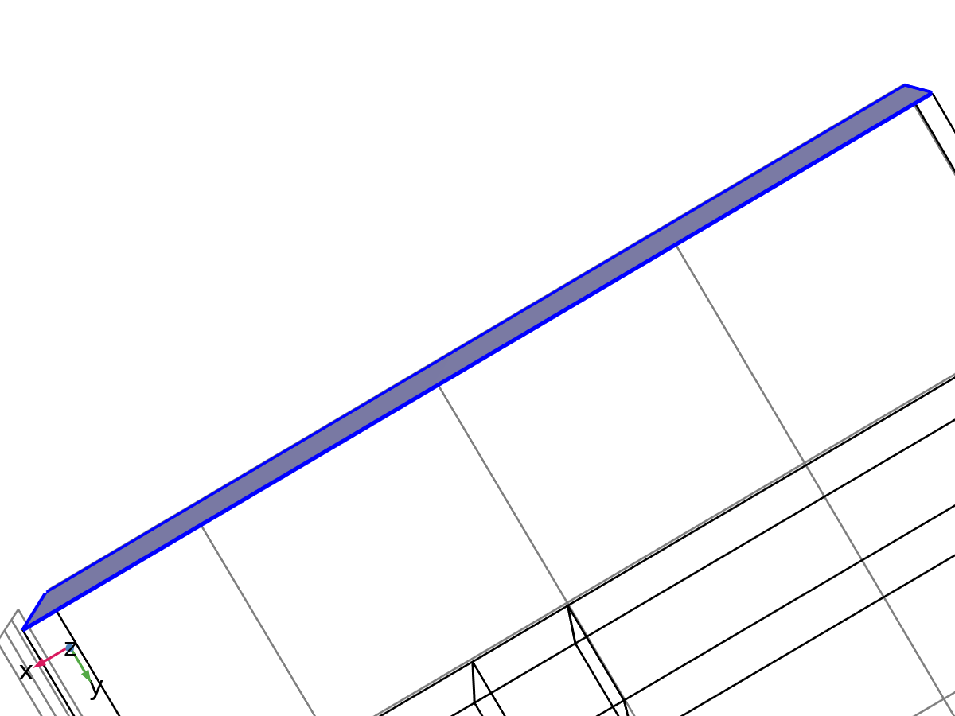
Symmetry 1
Selection
Geometric entity level | Boundary
Name | Sym y0
Selection | Named box4: Geometry geom1: Dimension 2: Boundary 2

Equations



Variables
Name | Expression | Unit | Description | Selection
spf.ubndx | 0 | m/s | Velocity at boundary, x-component | Boundary 2
spf.ubndy | 0 | m/s | Velocity at boundary, y-component | Boundary 2
spf.ubndz | 0 | m/s | Velocity at boundary, z-component | Boundary 2

Constraints
Constraint | Constraint force | Shape function | Selection | Details
(u-spf.ubndx)*spf.nx+(v-spf.ubndy)*spf.ny+(w-spf.ubndz)*spf.nz | test(u-spf.ubndx)*spf.nx+test(v-spf.ubndy)*spf.ny+test(w-spf.ubndz)*spf.nz | Lagrange (Quadratic) | Boundary 2 | Elemental

Symmetry 2
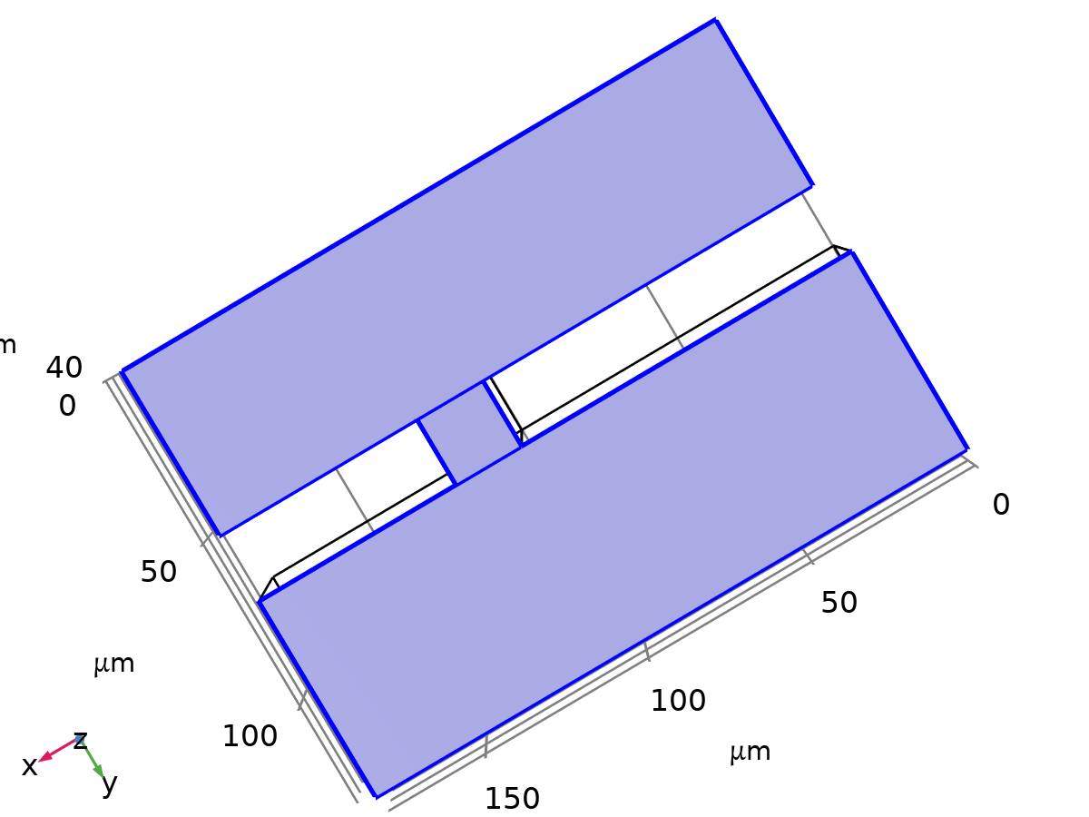
Symmetry 2
Selection
Geometric entity level | Boundary
Name | Sym zmid
Selection | Named box5: Geometry geom1: Dimension 2: Boundaries 4, 9, 14

Equations

Variables
Name | Expression | Unit | Description | Selection
spf.ubndx | 0 | m/s | Velocity at boundary, x-component | Boundaries 4, 9, 14
spf.ubndy | 0 | m/s | Velocity at boundary, y-component | Boundaries 4, 9, 14
spf.ubndz | 0 | m/s | Velocity at boundary, z-component | Boundaries 4, 9, 14

Constraints
Constraint | Constraint force | Shape function | Selection | Details
(u-spf.ubndx)*spf.nx+(v-spf.ubndy)*spf.ny+(w-spf.ubndz)*spf.nz | test(u-spf.ubndx)*spf.nx+test(v-spf.ubndy)*spf.ny+test(w-spf.ubndz)*spf.nz | Lagrange (Quadratic) | Boundaries 4, 9, 14 | Elemental

Mesh 1
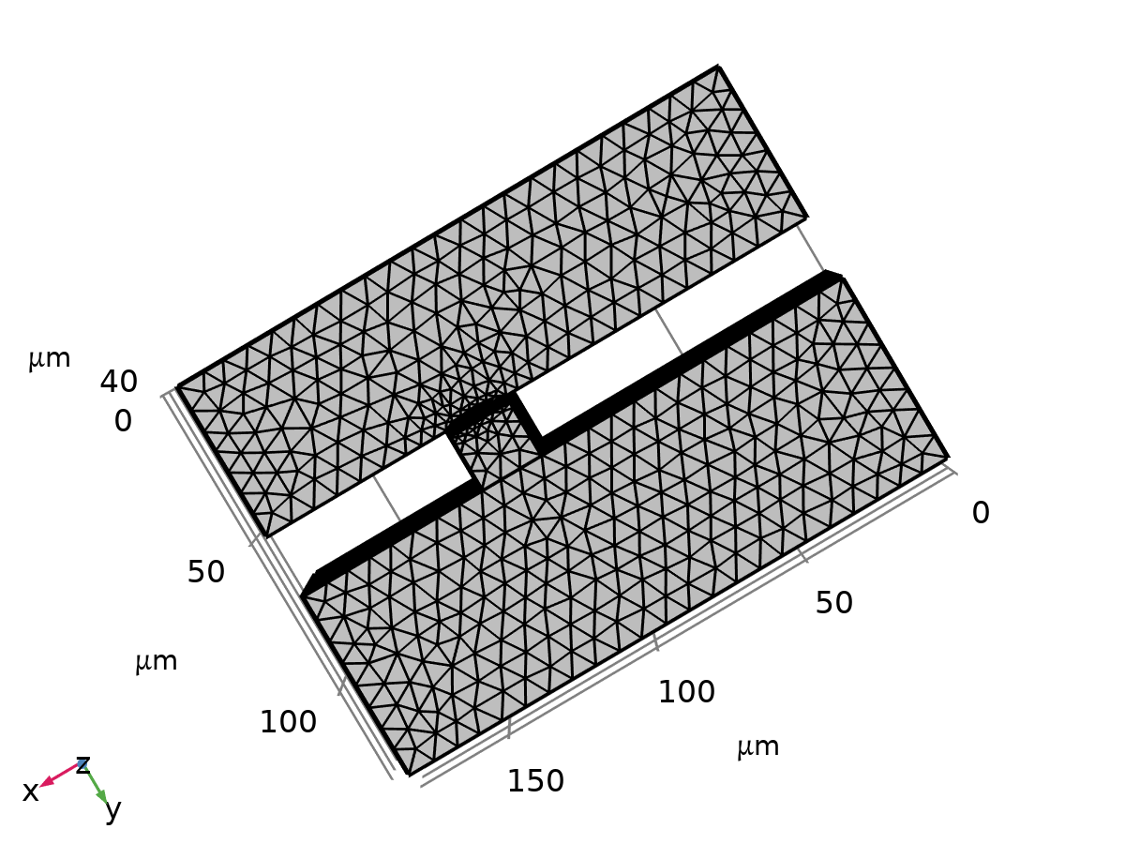
Mesh 1
Mesh statistics
Description | Value
Status | Complete mesh
Mesh vertices | 12471
Tetrahedra | 51814
Pyramids | 384
Prisms | 4328
Number of elements | 56526
Minimum element quality | 0.1024
Average element quality | 0.699
Element volume ratio | 0.0021641
Mesh volume | 1.414E6 µm³

Size (size)
Settings
Description | Value
Calibrate for | Fluid dynamics
Maximum element size | 8[um]
Minimum element size | 1.324
Curvature factor | 0.8
Resolution of narrow regions | 0.5
Maximum element growth rate | 1.3
Predefined size | Coarser
Custom element size | Custom

Size 1 (size1)
Selection
Geometric entity level | Boundary
Name | Wall gap
Selection | Named box6: Geometry geom1: Dimension 2: Boundary 12

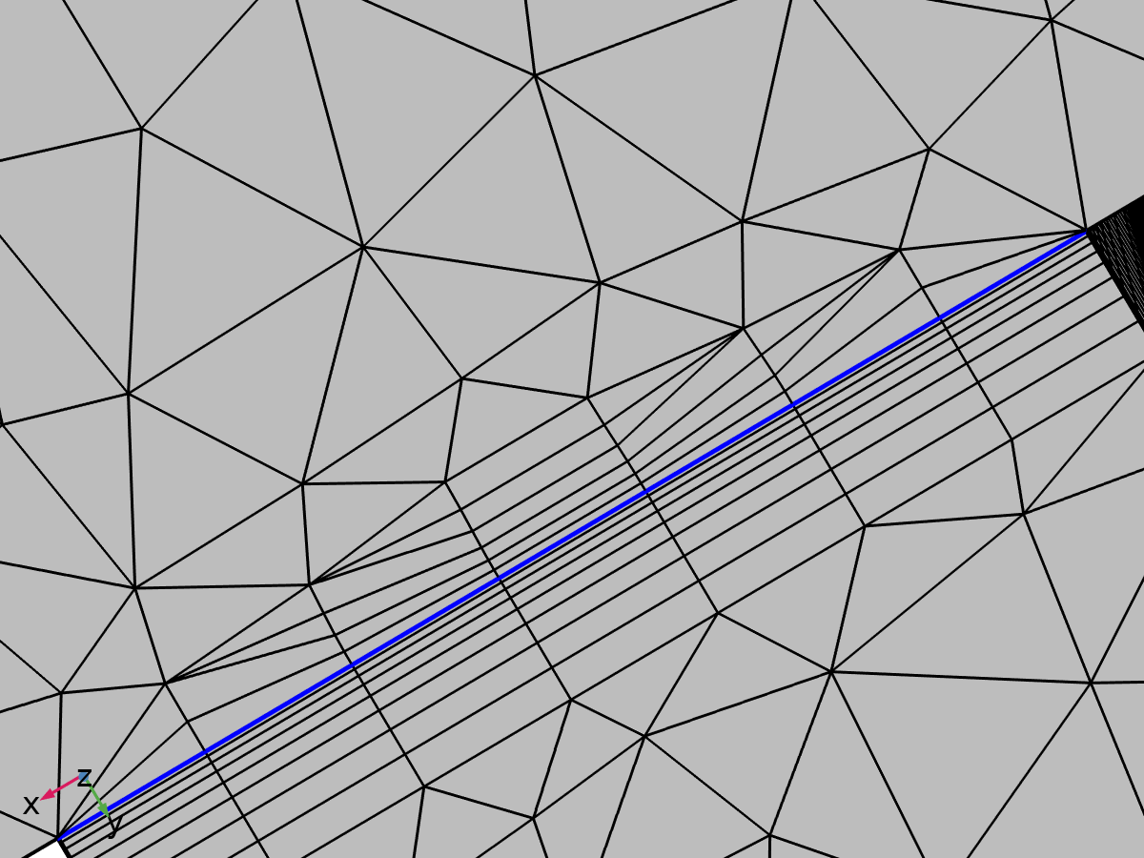
Size 1
Settings
Description | Value
Calibrate for | Fluid dynamics
Maximum element size | 3[um]
Minimum element size | 1.91
Minimum element size | Off
Curvature factor | 0.6
Curvature factor | Off
Resolution of narrow regions | 0.7
Resolution of narrow regions | Off
Maximum element growth rate | 1.15
Maximum element growth rate | Off
Custom element size | Custom

Boundary Layers 1 (bl1)
Selection
Geometric entity level | Domain
Selection | Geometry geom1

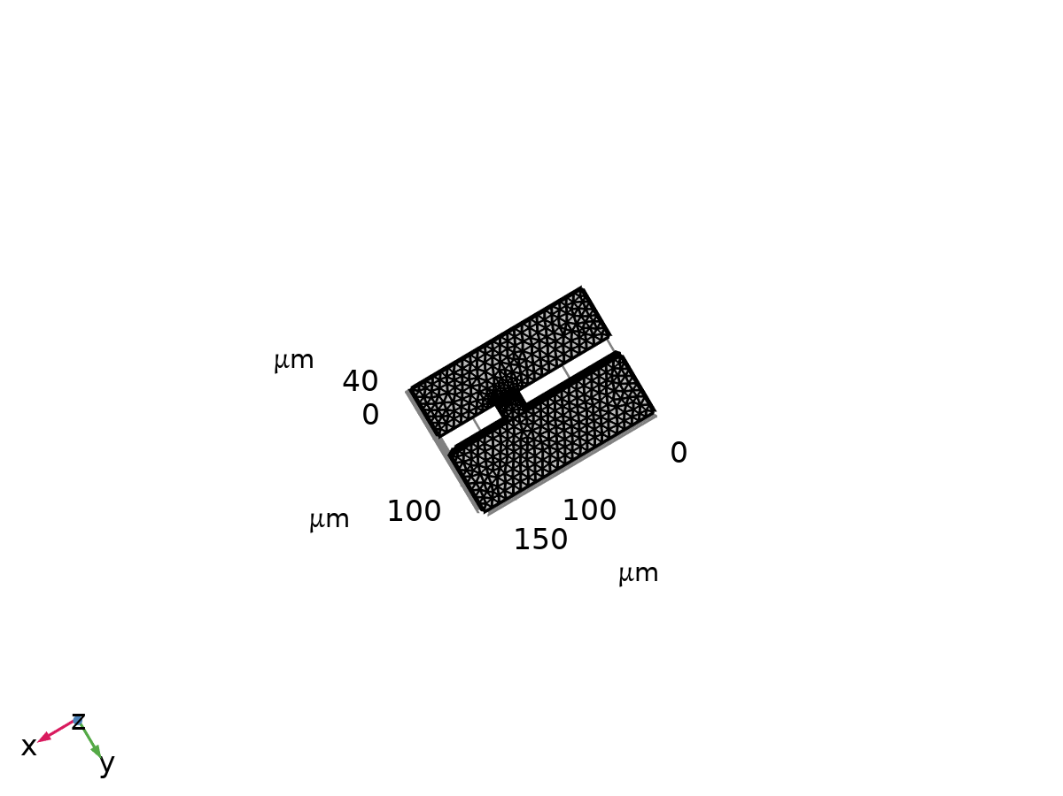
Boundary Layers 1
Information
Description | Value
Last build time | 3 seconds
Built with | COMSOL 6.3.0.420 (win64), Jun 13, 2026, 11:18:02 AM

Boundary Layer Properties (blp)
Selection
Geometric entity level | Boundary
Name | Wall gap
Selection | Named box6: Geometry geom1: Dimension 2: Boundary 12

Boundary Layer Properties
Settings
Description | Value
Stretching factor | 1.3
Thickness specification | First layer
Thickness | 0.1[um]

Free Tetrahedral 1 (ftet1)
Selection
Geometric entity level | Remaining

Free Tetrahedral 1
Settings
Description | Value
Avoid inverted curved elements | On

Information
Description | Value
Last build time | < 1 second
Built with | COMSOL 6.3.0.420 (win64), Jun 13, 2026, 2:48:33 PM

Study 1
Computation information
Computation time | 1 min 33 s

Stationary
Study settings
Description | Value
Include geometric nonlinearity | Off

Physics and variables selection
Key | Solve for
Creeping Flow (spf) | On

Store in output
Interface | Output | Selection
Creeping Flow (spf) | Physics controlled

Mesh selection
Component | Mesh
Component 1 | Mesh 1

Solver Configurations

Solution 1

Compile Equations: Stationary (st1)
Study and step
Description | Value
Use study
Use study step | Stationary

Log
<---- Compile Equations: Stationary in Study 1/Solution 1 (sol1) ---------------
Started at Jun 13, 2026, 2:49:59 PM.
Geometry shape function: Linear Lagrange
Running on Intel64 Family 6 Model 106 Stepping 6, GenuineIntel.
Using 1 socket with 4 cores in total on egrvdi-wa1012.
Available memory: 16.38 GB.
Time: 5 s.
Physical memory: 1.64 GB
Virtual memory: 2.04 GB
Ended at Jun 13, 2026, 2:50:04 PM.
----- Compile Equations: Stationary in Study 1/Solution 1 (sol1) -------------->

Dependent Variables 1 (v1)
General
Description | Value
Defined by study step

Log
<---- Dependent Variables 1 in Study 1/Solution 1 (sol1) -----------------------
Started at Jun 13, 2026, 2:50:04 PM.
Solution time: 0 s.
Physical memory: 1.64 GB
Virtual memory: 2.04 GB
Ended at Jun 13, 2026, 2:50:04 PM.
----- Dependent Variables 1 in Study 1/Solution 1 (sol1) ---------------------->

Pressure (comp1.p) (comp1_p)
General
Description | Value
Field components | comp1.p

Velocity Field (comp1.u) (comp1_u)
General
Description | Value
Field components | {comp1.u, comp1.v, comp1.w}
Internal variables | comp1.spf.isFluidHasBeenSolved

Stationary Solver 1 (s1)
General
Description | Value
Defined by study step

Log
<---- Stationary Solver 1 in Study 1/Solution 1 (sol1) -------------------------
Started at Jun 13, 2026, 2:50:04 PM.
Nonlinear solver
Number of degrees of freedom solved for: 292917 (plus 1 internal DOFs).
Nonsymmetric matrix found.
Scales for dependent variables:
Pressure (comp1.p): 1
Velocity Field (comp1.u): 0.0073
Orthonormal null-space function used.
Iter SolEst ResEst Damping Stepsize #Res #Jac #Sol LinErr LinRes
1 60 7.2e+02 0.0100000 61 2 1 2 2.5e-14 3.2e-15
2 5.7 1.2e+04 0.1000000 6.4 3 2 4 1.5e-14 2.9e-15
3 8.7e-07 1.4e+05 1.0000000 0.65 4 3 6 6.3e-16 7.1e-16
4 1.1e-11 6.8e+03 1.0000000 1.8e-06 6 4 8 4.8e-16 7.1e-16
Solution time: 88 s. (1 minute, 28 seconds)
Physical memory: 8.7 GB
Virtual memory: 9.83 GB
Ended at Jun 13, 2026, 2:51:32 PM.
----- Stationary Solver 1 in Study 1/Solution 1 (sol1) ------------------------>

Direct (dDef)
General
Description | Value
Solver | PARDISO

Advanced (aDef)
Assembly settings
Description | Value
Reuse sparsity pattern | On

Fully Coupled 1 (fc1)
General
Description | Value
Linear solver

Method and termination
Description | Value
Initial damping factor | 0.01
Maximum number of iterations | 100

Results

Datasets

Study 1/Solution 1
Solution
Description | Value
Solution
Component | Component 1 (comp1)

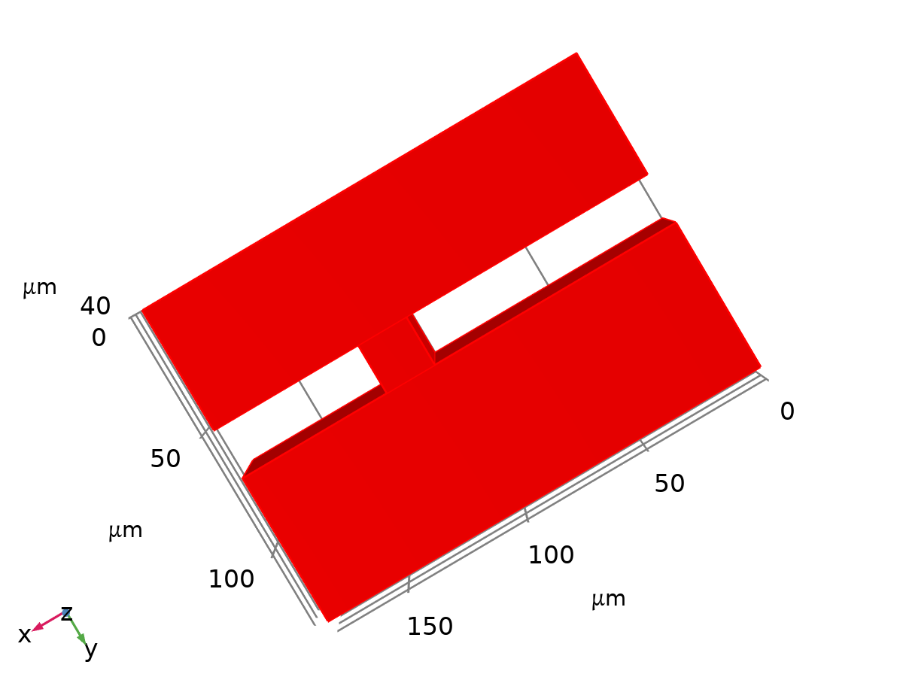
Dataset: Study 1/Solution 1

Exterior Walls
Data
Description | Value
Dataset

Parameterization
Description | Value
x- and y-axes | Surface parameters

δ_skim
Data
Description | Value
Dataset

Plane data
Description | Value
Plane type | General
Plane entry method | Point and normal vector
Point | {75[um], 0, 0}
Normal vector | {1, 0, 0}

Advanced
Description | Value
Space variables | {cpl1x, cpl1y}
Normal variables | {cpl1nx, cpl1ny, cpl1nz}

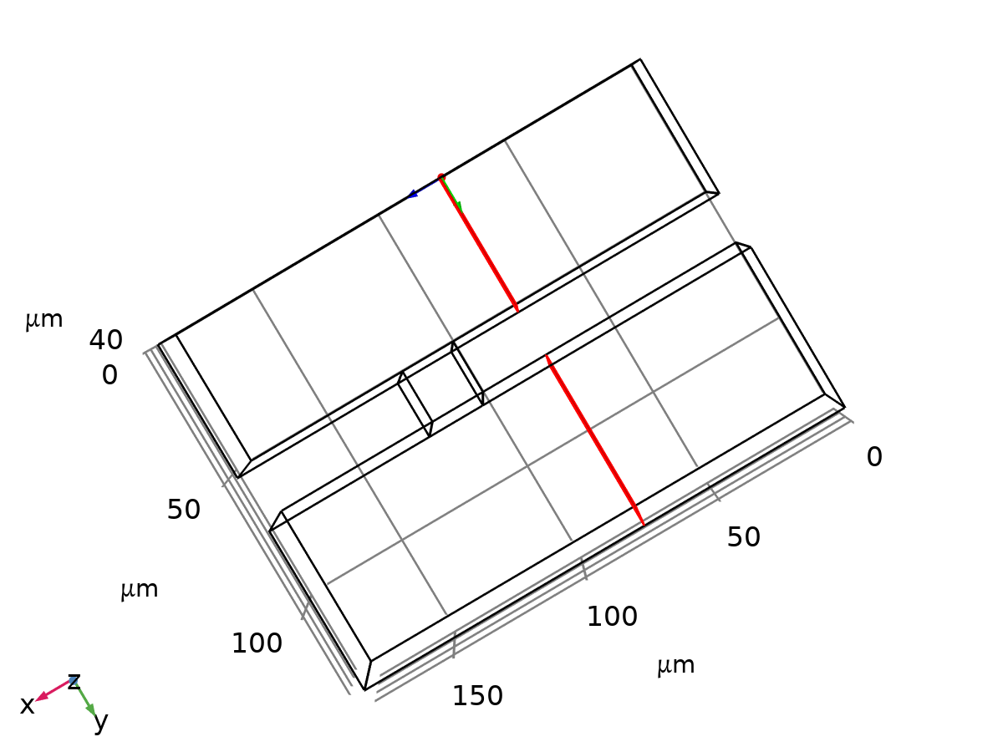
Dataset: δ_skim

Derived Values

Q_in
Output
Evaluated in

Data
Description | Value
Dataset

Expressions
Expression | Unit | Description
u | m^3/s | Velocity field, x-component

Integration settings
Description | Value
Integration order | 4

Q_cout
Output
Evaluated in

Data
Description | Value
Dataset

Expressions
Expression | Unit | Description
u | m^3/s | Velocity field, x-component

Integration settings
Description | Value
Integration order | 4

Q_sout
Output
Evaluated in

Data
Description | Value
Dataset

Expressions
Expression | Unit | Description
u | m^3/s | Velocity field, x-component

Integration settings
Description | Value
Integration order | 4

Global Evaluation 1
Output
Evaluated in

Data
Description | Value
Dataset

Expressions
Expression | Unit | Description
intop_in(u) | m^3/s
intop_cout(u) | m^3/s
intop_sout(u) | m^3/s
(intop_in(u)-intop_cout(u)-intop_sout(u))/intop_in(u) | 1
intop_sout(u)/intop_in(u) | 1

Tables

Table 1
Q_in
Velocity field, x-component (m^3/s)
3.2749E-10

Table 2
Q_cout
Velocity field, x-component (m^3/s)
3.2733E-10

Table 3
Q_sout
Velocity field, x-component (m^3/s)
1.625E-13

Table 4
Global Evaluation 1
intop_in(u) (m^3/s) | intop_cout(u) (m^3/s) | intop_sout(u) (m^3/s) | (intop_in(u)-intop_cout(u)-intop_sout(u))/intop_in(u) (1) | intop_sout(u)/intop_in(u) (1)
3.2749E-10 | 3.2733E-10 | 1.625E-13 | 3.0893E-15 | 4.9621E-4

Plot Groups

Velocity (spf)
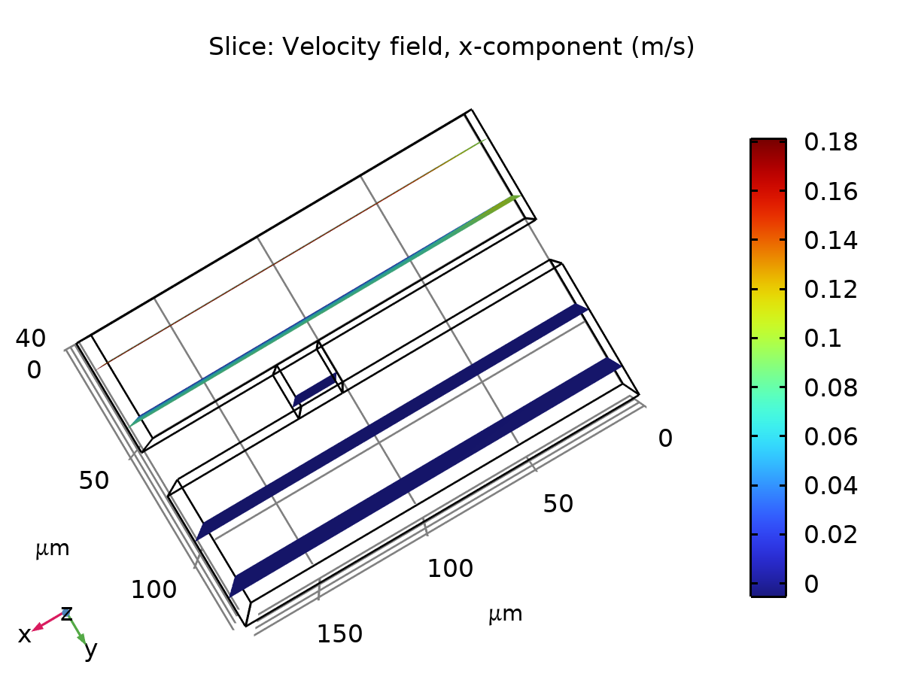
Slice: Velocity field, x-component (m/s)

Pressure (spf)
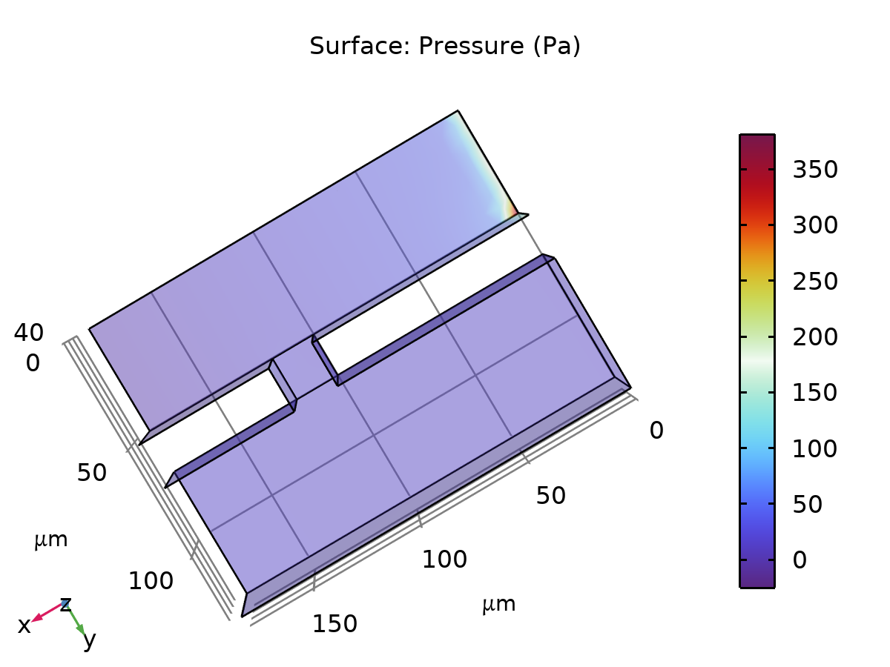
Surface: Pressure (Pa)

